Observability Zero TO Hero

aws cli:

curl "https://awscli.amazonaws.com/awscli-exe-linux-x86_64.zip" -o "awscliv2.zip"

unzip awscliv2.zip

sudo ./aws/install

Eksctl:

curl -LO "https://github.com/eksctl-io/eksctl/releases/latest/download/eksctl_Linux_amd64.tar.gz"

tar -xzf eksctl_Linux_amd64.tar.gz

sudo mv eksctl /usr/local/bin

kubectl:

VERSION=$(curl -Ls https://dl.k8s.io/release/stable.txt)

echo $VERSION

curl -LO "https://dl.k8s.io/release/${VERSION}/bin/linux/amd64/kubectl"

chmod +x kubectl

sudo mv kubectl /usr/local/bin/

kubectl version --client

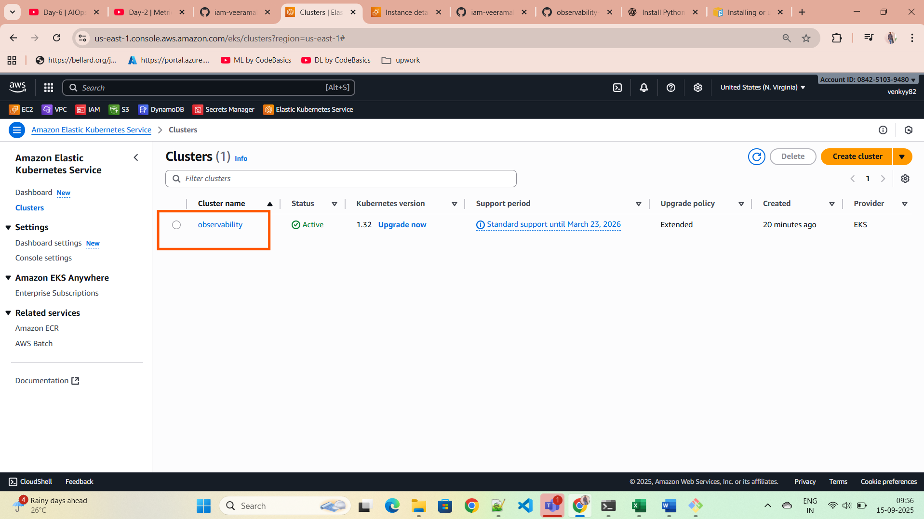

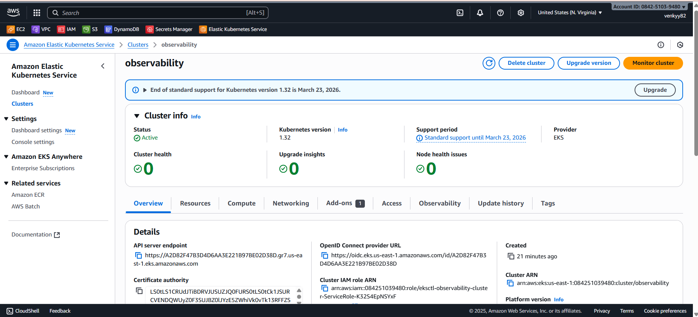

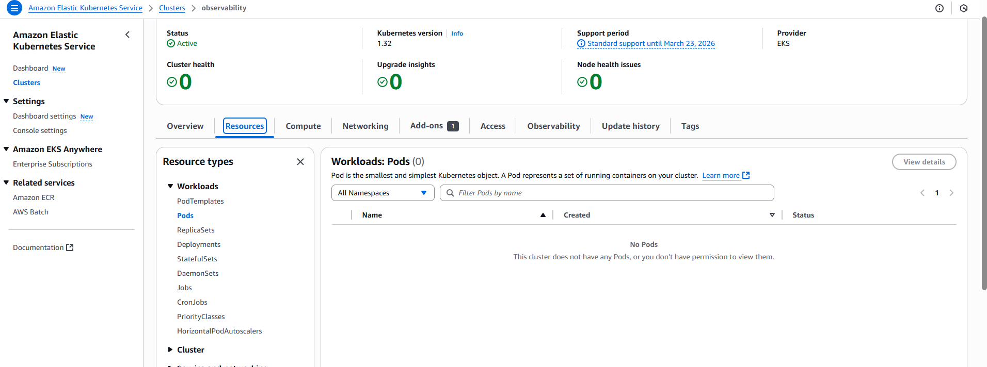

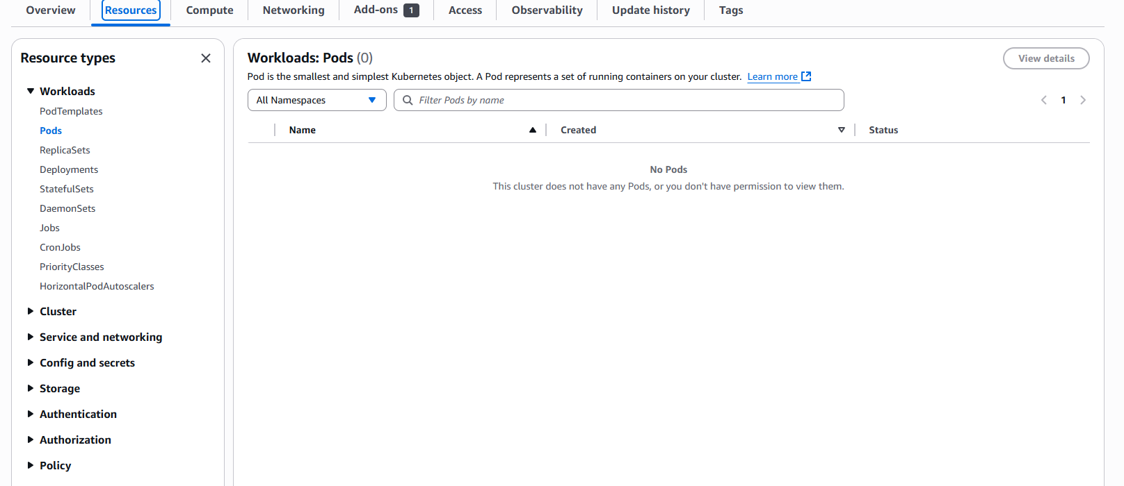

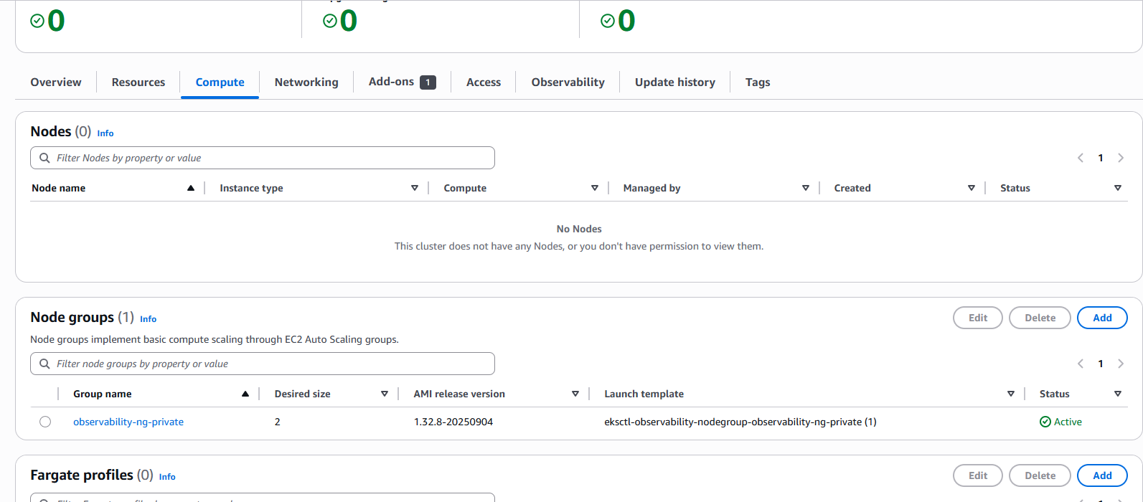

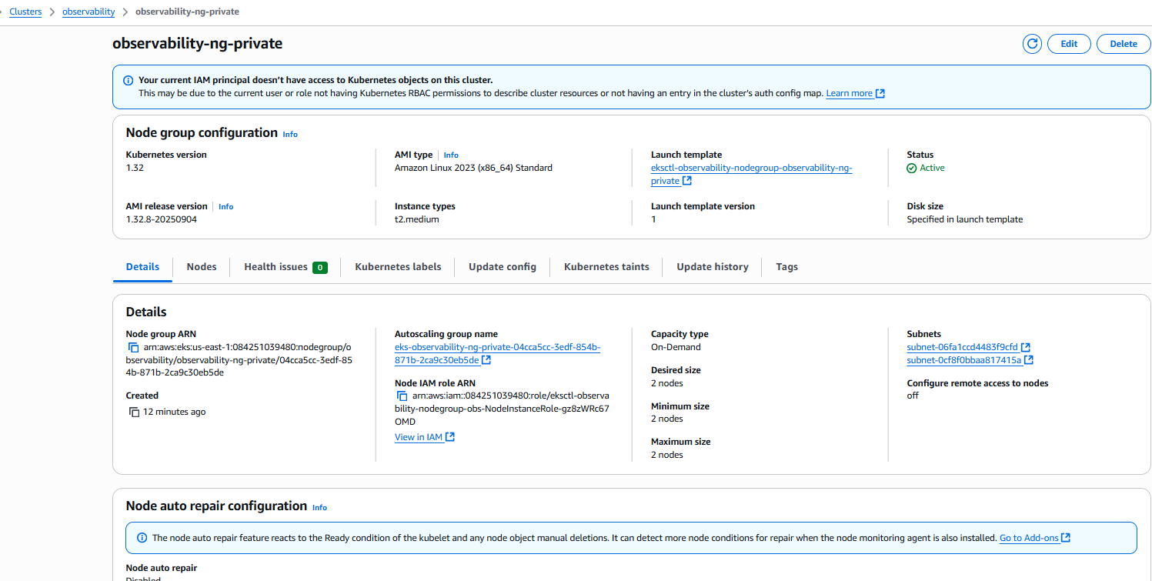

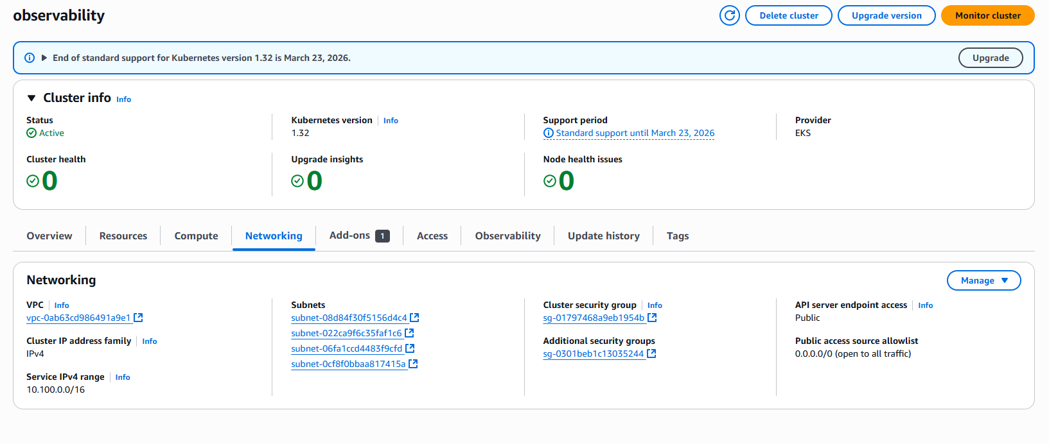

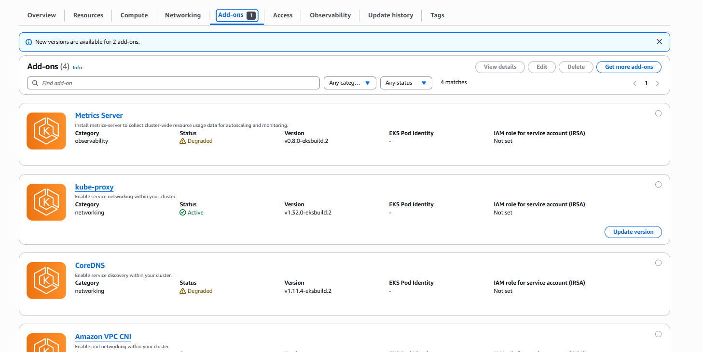

Node Groups Ec2 instances:

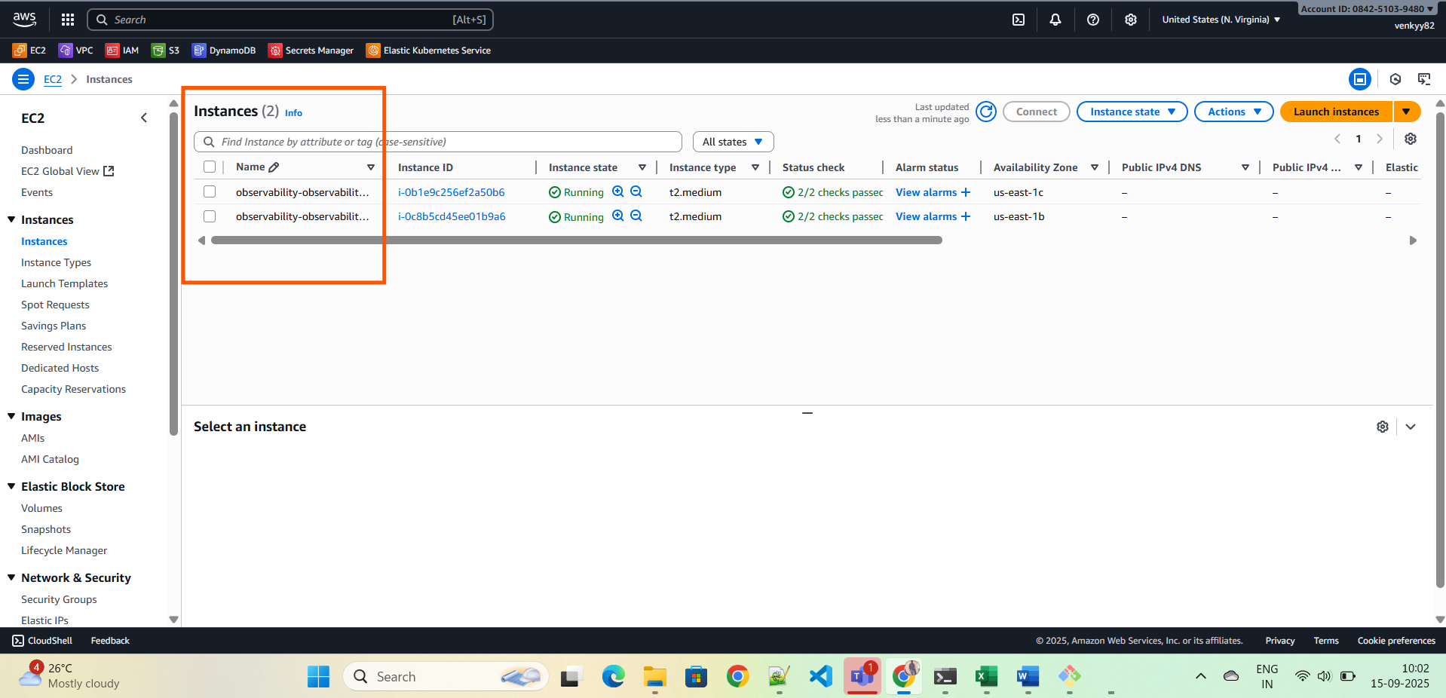

IAM Role which was attached to ec2 instances.

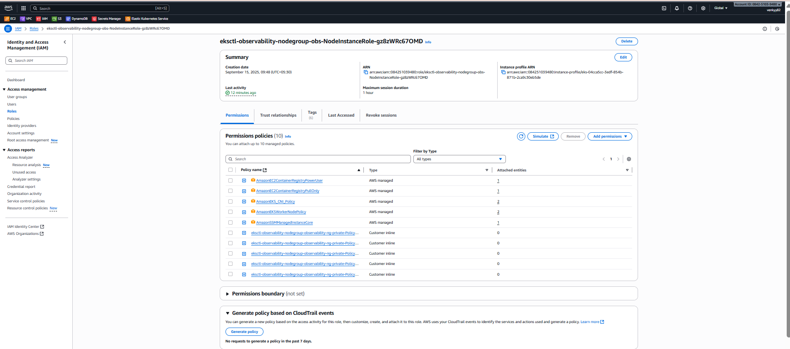

Created 1 vpc

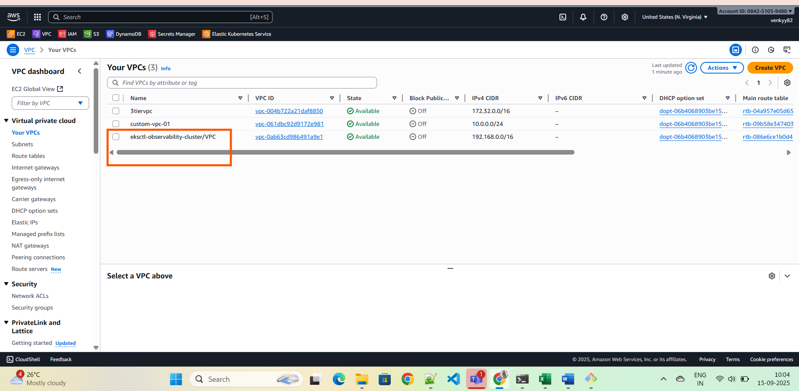

Subnets:

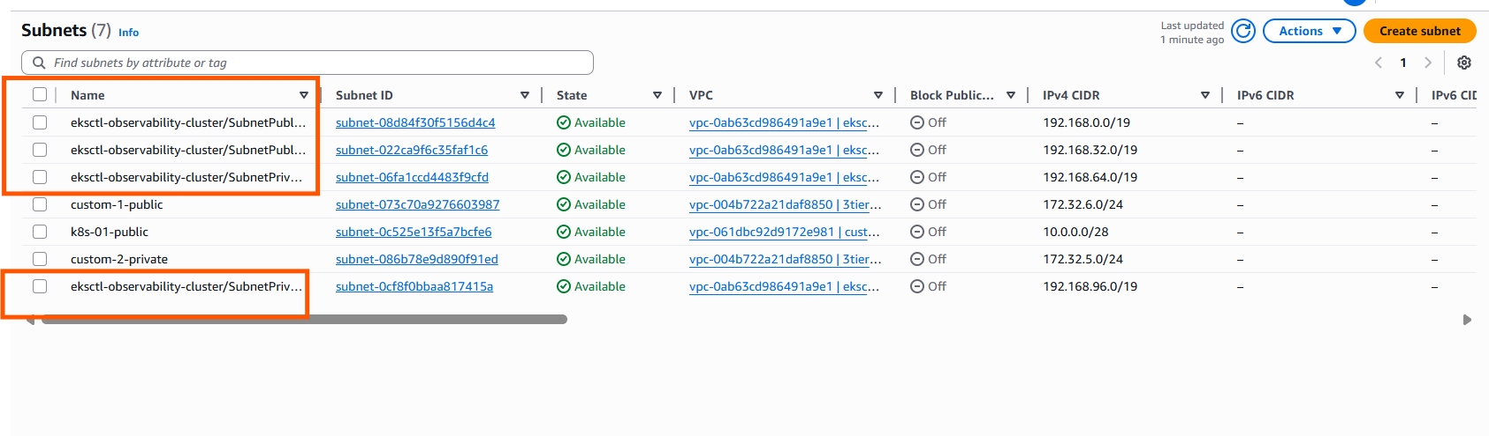

RTs

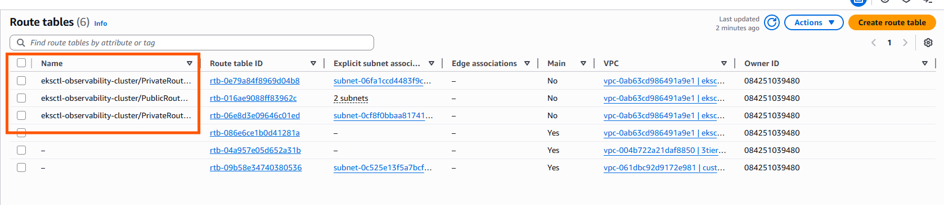

IGW

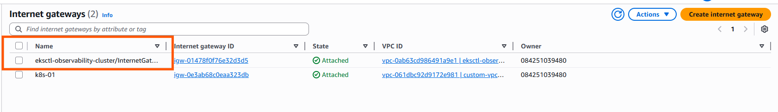

Installed monitoring stack in k8s:

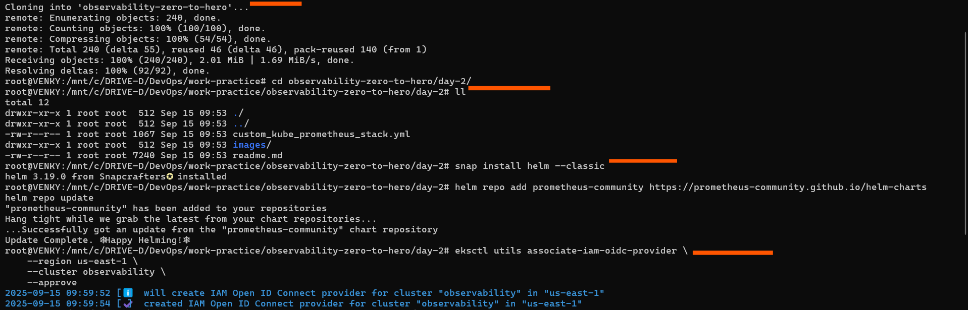

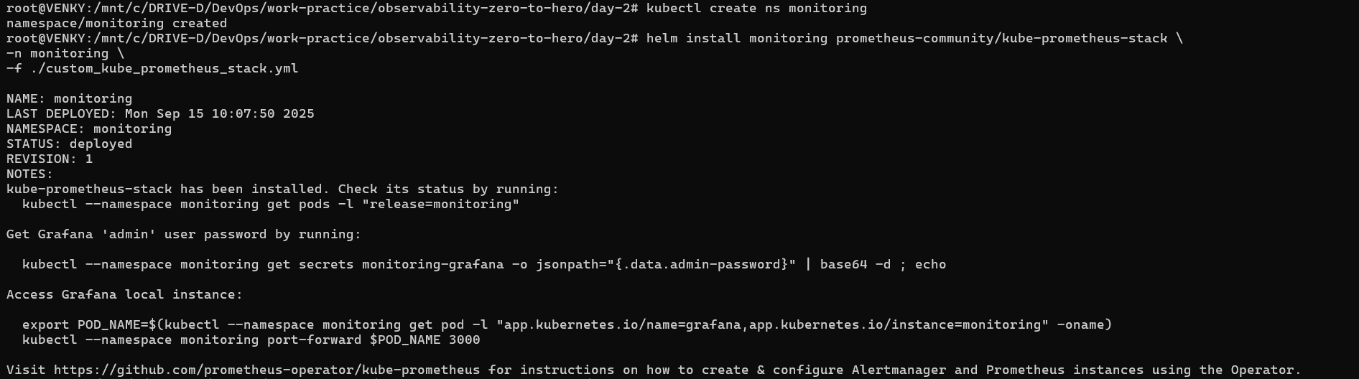

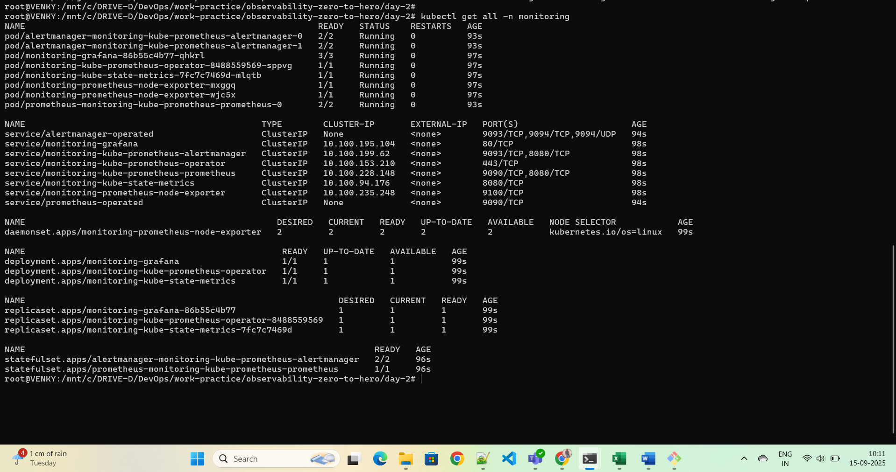

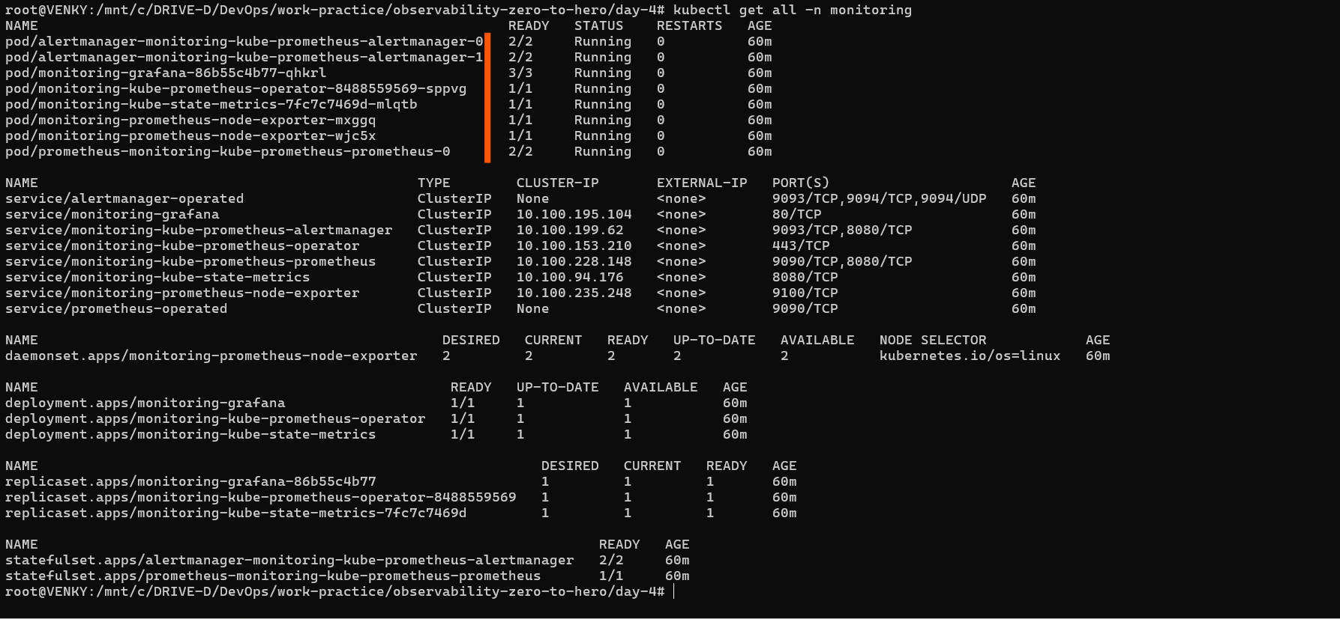

Open the port number in SG and then run below command

sudo ufw allow 9090

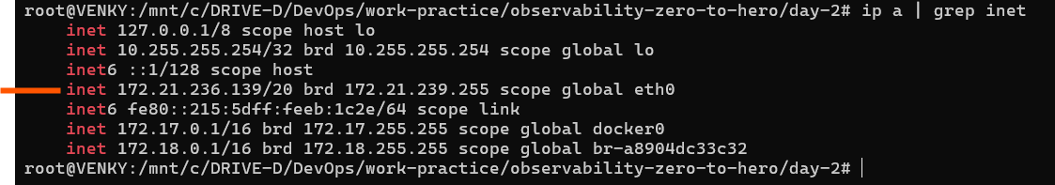

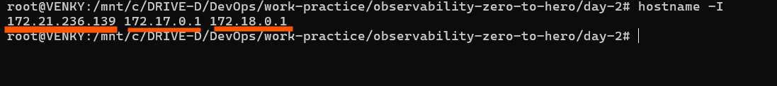

Enter the below command

kubectl port-forward service/prometheus-operated -n monitoring 9090:9090 --address 0.0.0.0

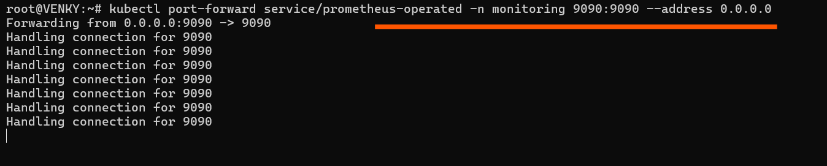

And finally access the Prometheus in chrome:

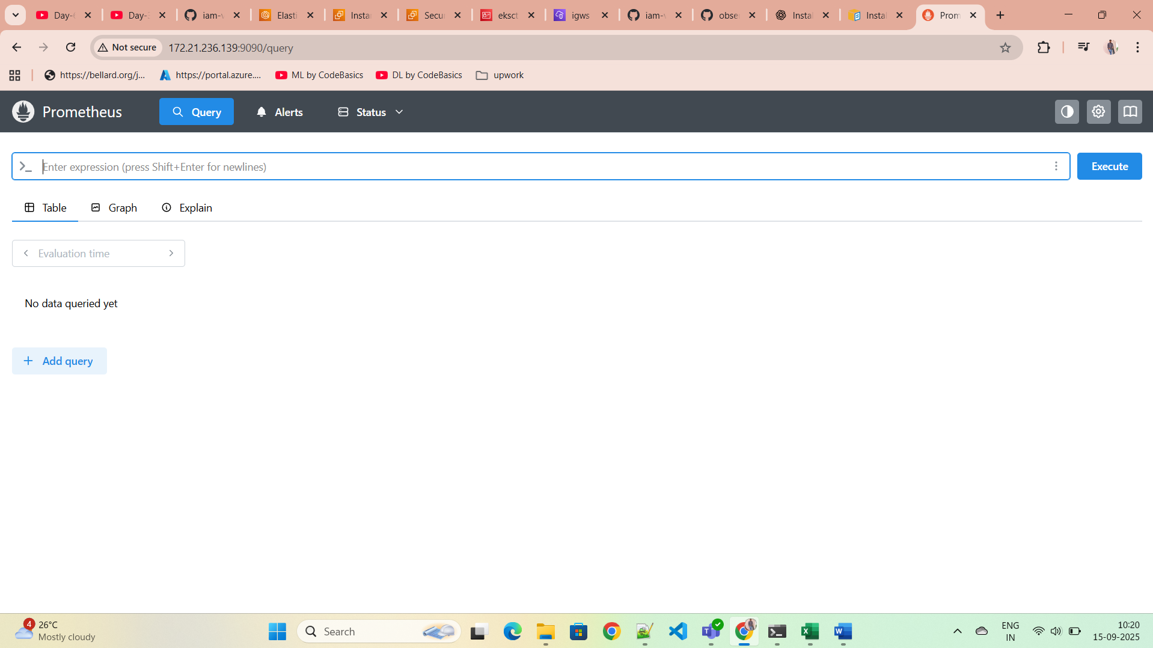

Now access Grafana

sudo ufw allow 8080

kubectl port-forward service/monitoring-grafana -n monitoring 8080:80 --address 0.0.0.0

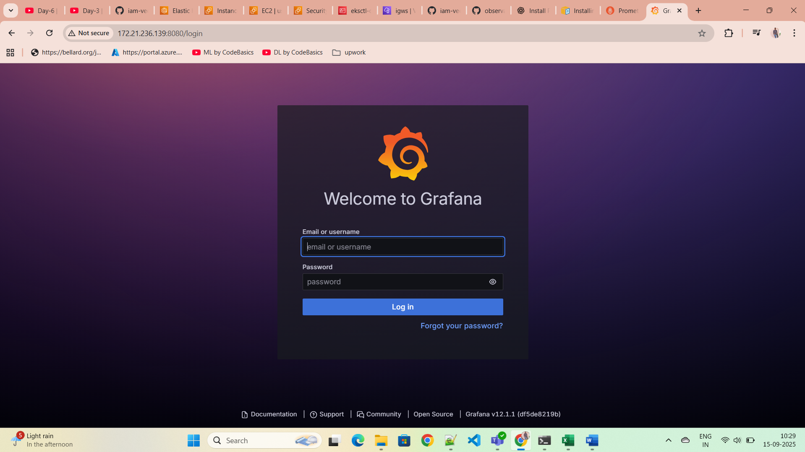

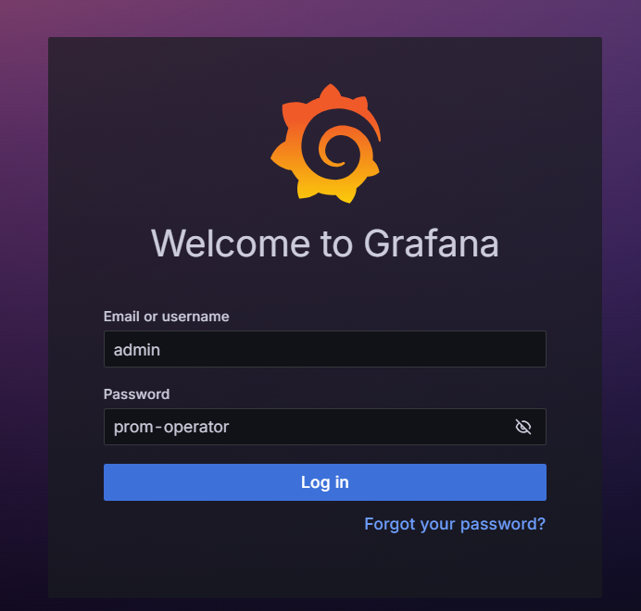

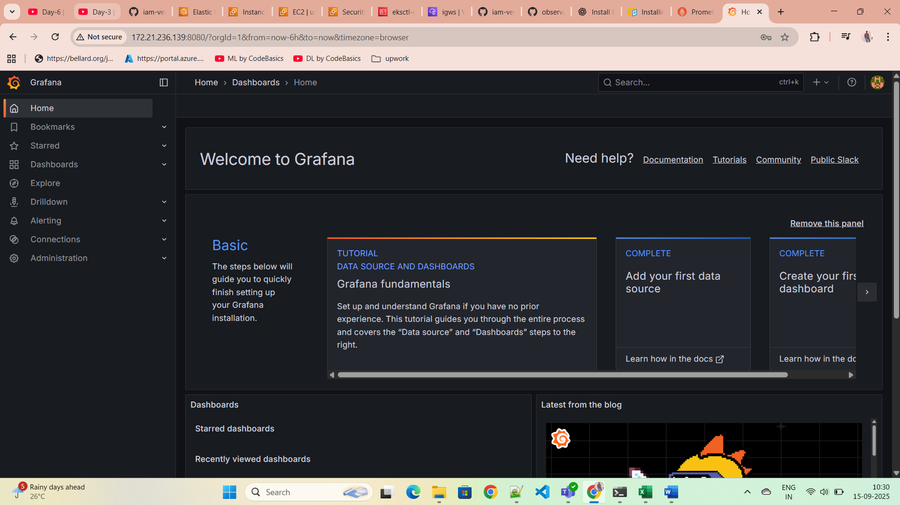

Now we will install busybox pods

kubectl run busybox-crash --image=busybox -- /bin/sh -c "exit 1"

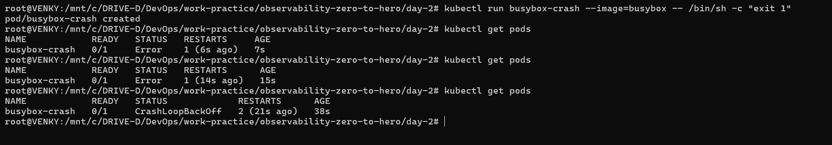

We can see the logs in Promethues by using promQL

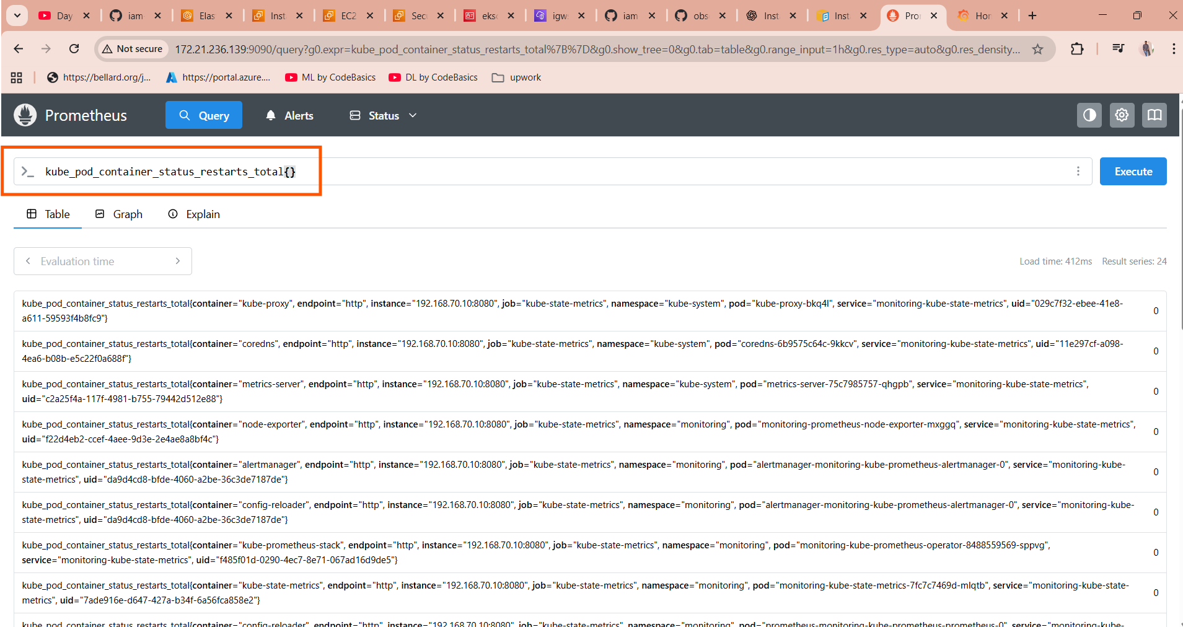

In graph also we can see

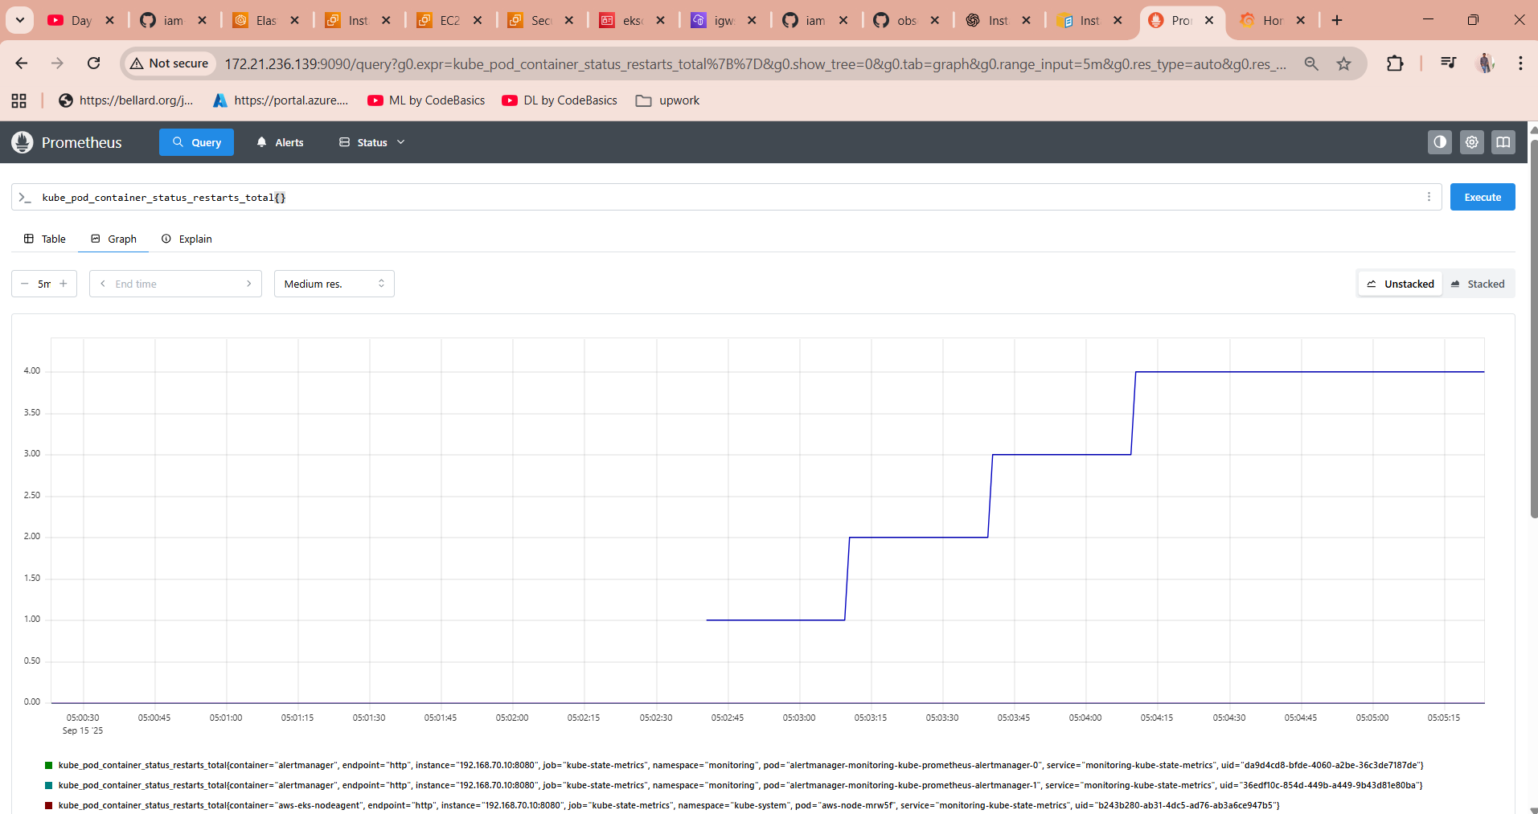

Prometheus also supports alerts

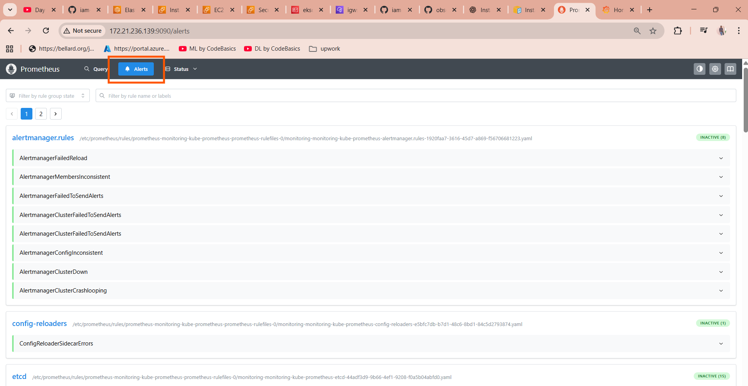

It supports visual graphs also 3 factors it supports.

$

Deploying a sample application

kubectl create ns dev

kubectl apply -k kubernetes-manifest/

updated the kustomization.yaml file with

namespace: dev

resources:

- deployment-svc-a.yml

- service-svc-a.yml

- deployment-svc-b.yml

- service-svc-b.yml

If we mention api and kind getting error.

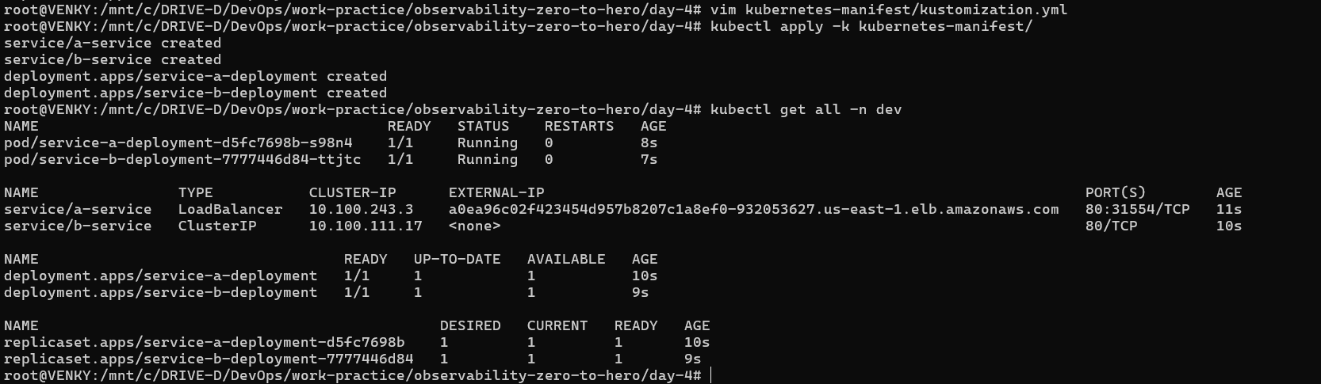

Copy the service load balancer external ipa nd paste in the chrome

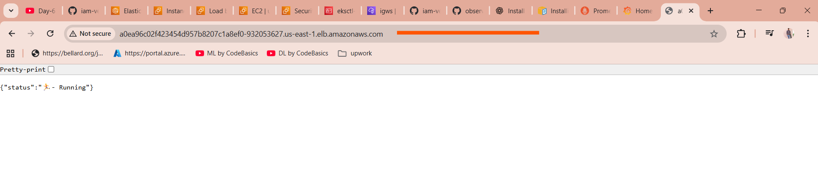

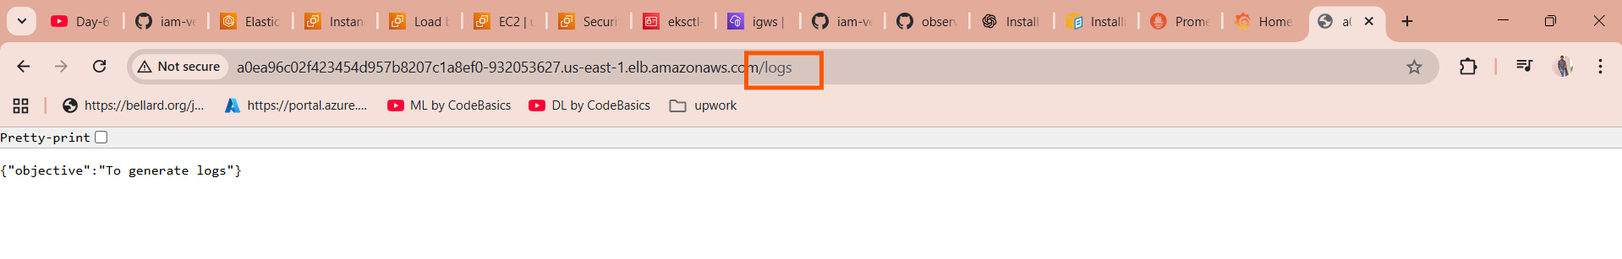

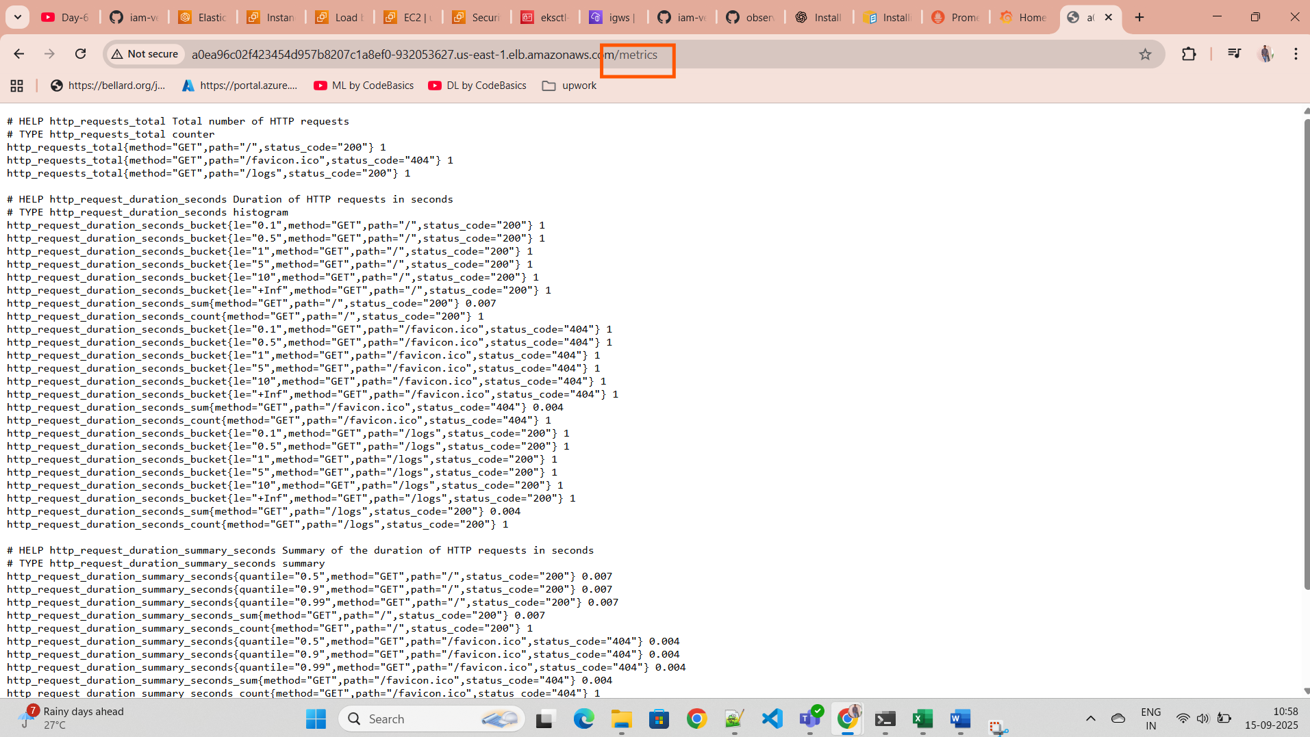

When ever we deploy one application by default prometeus cant read those application metrics

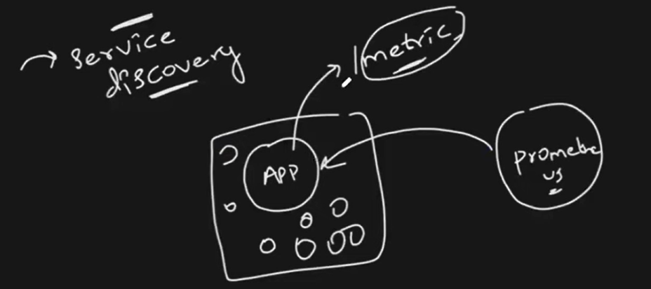

By using service discovery we can connect the prometues to read those application metrics.

Before setting up service discovery we did not get any response

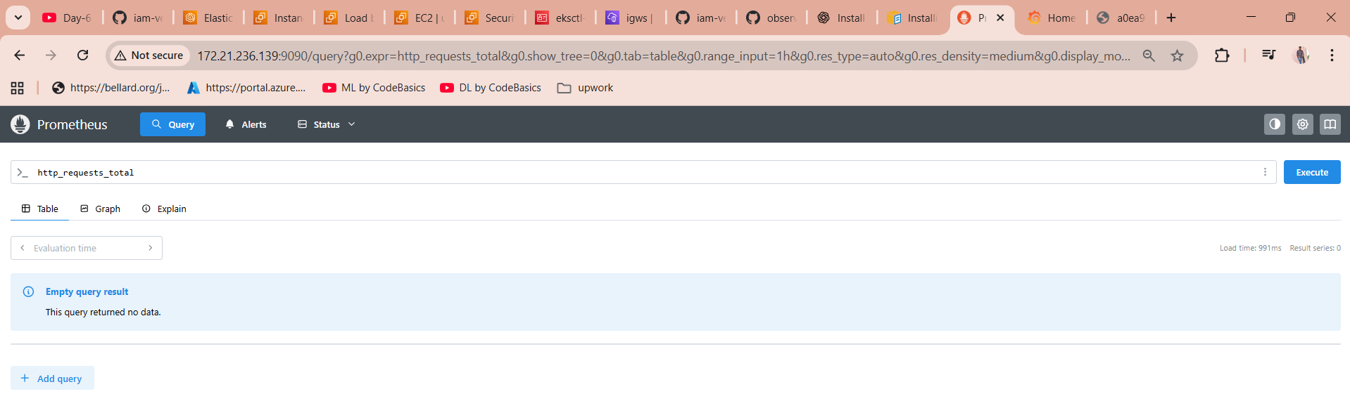

For that we can apply the below command in that directory we have configured everything

Kubectl apply -k alerts-alertmanager-servicemonitor-manifest

In secret file under password section update with any sample base64 encoded passowrd

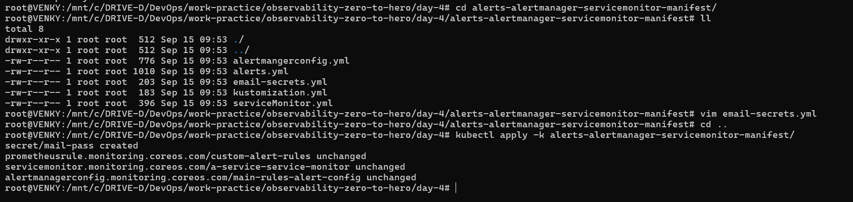

After setting up the service discovery we are getting the responce

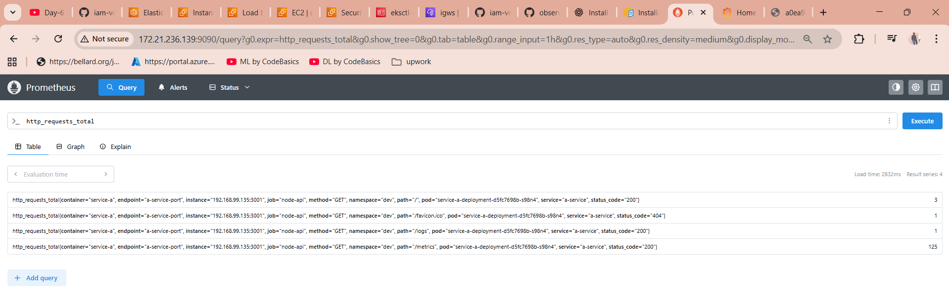

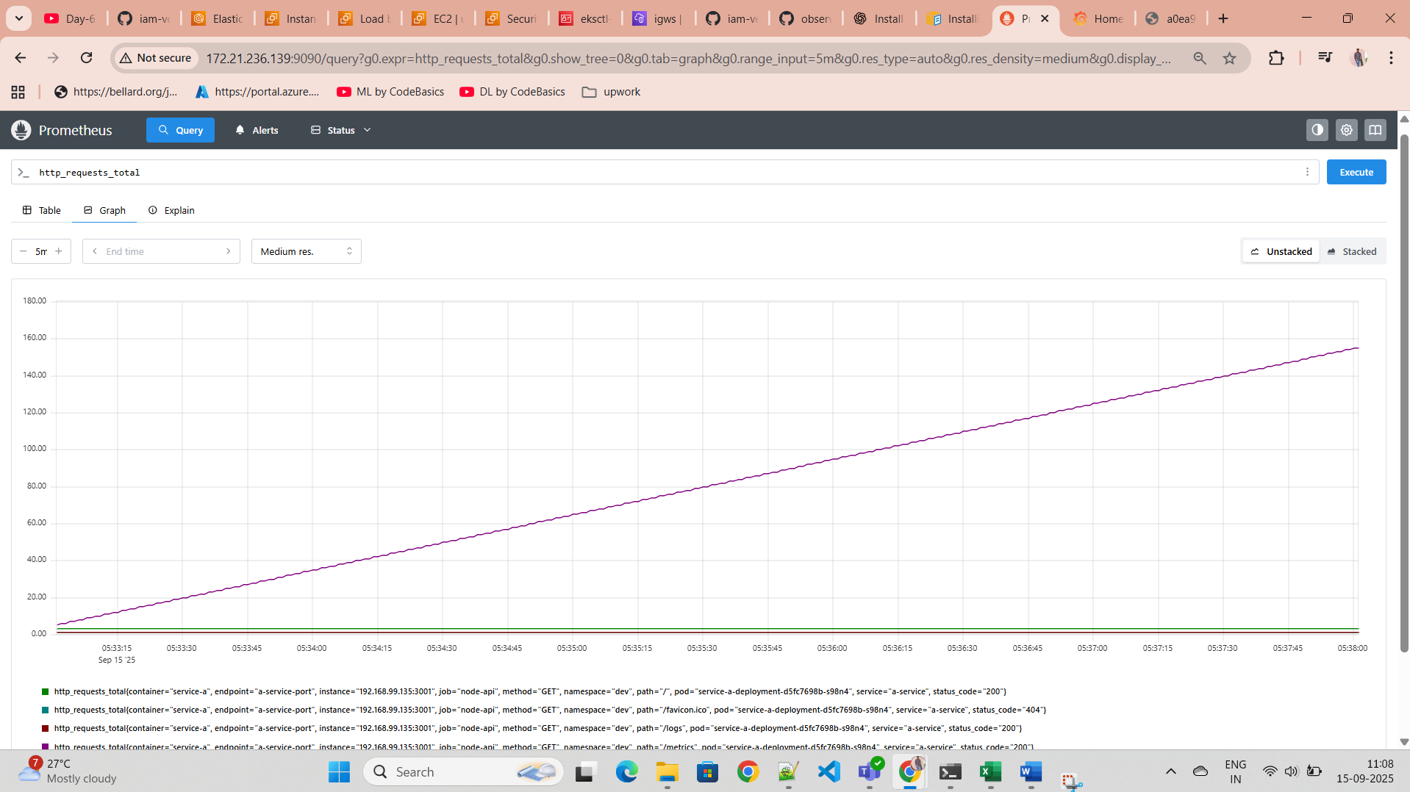

Create gmail app passwords to setup alert configuration

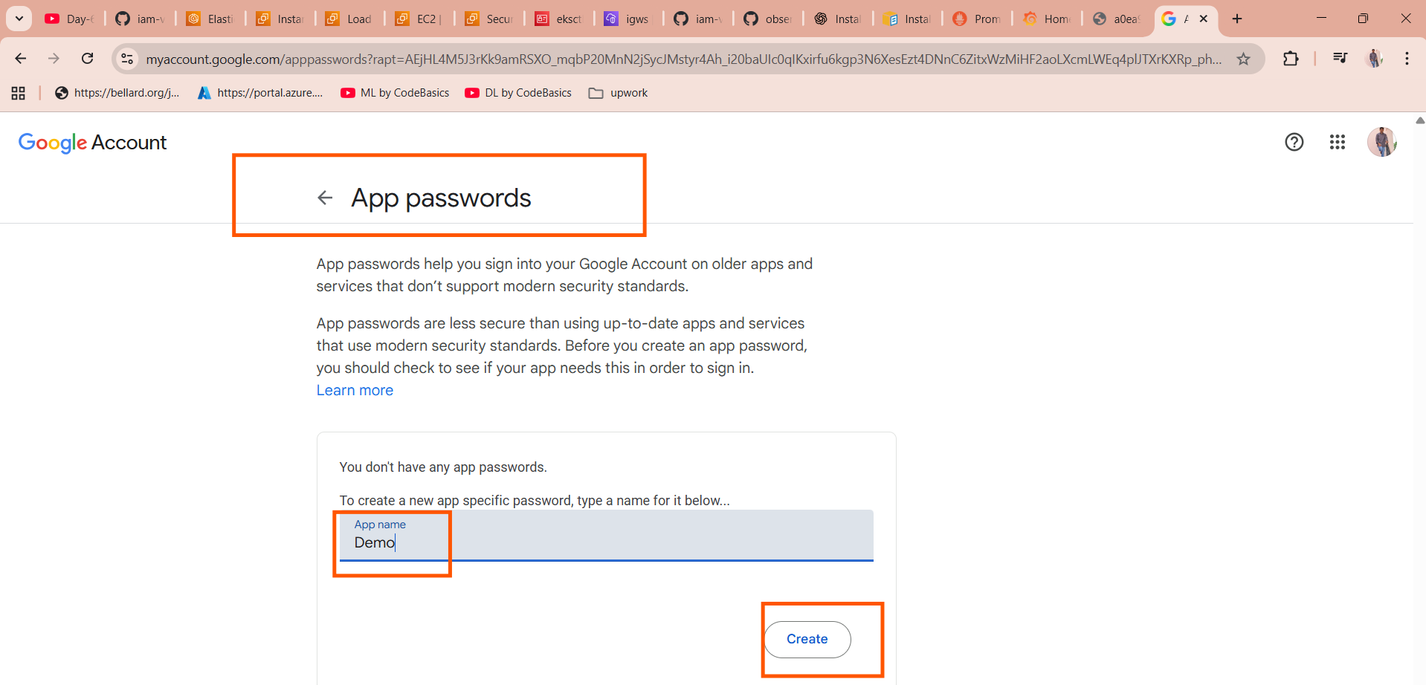

Copy the password and encode that with base64

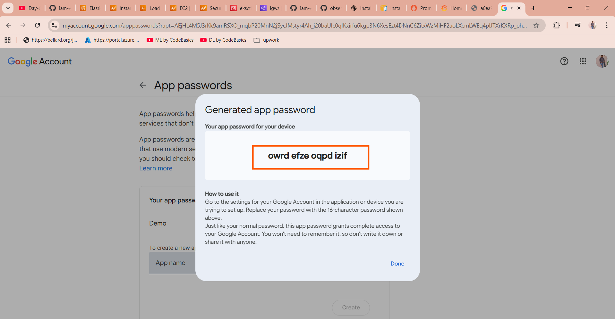

**owrd efze oqpd izif**



Then update the vim email-secrets.yml and paste the password over there

And then again need to update the vim alertmangerconfig.yml need to mention email address where ever required

Then finally run the command

kubectl apply -k alerts-alertmanager-servicemonitor-manifest/

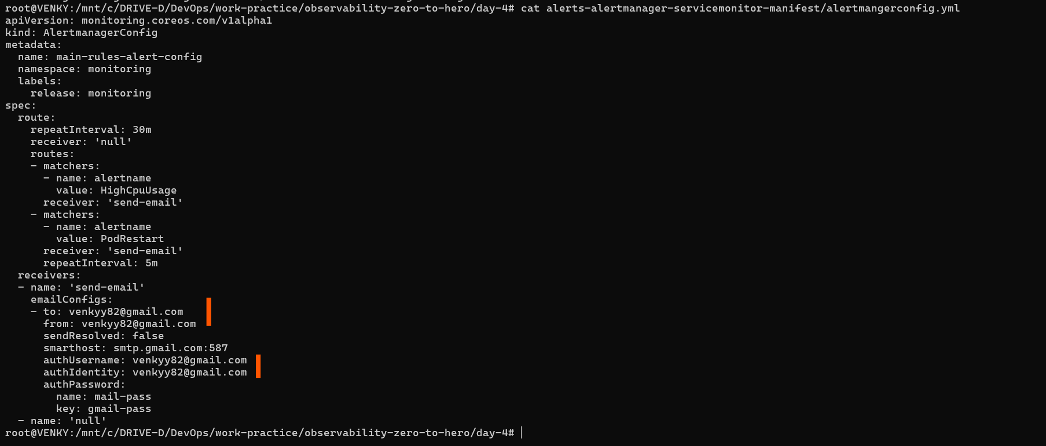

here if we see pods status



Its running state

If do /crash wantedly we can see the pods status



We can see we are getting the alerts to my email

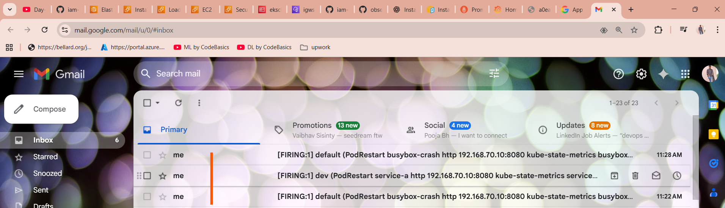

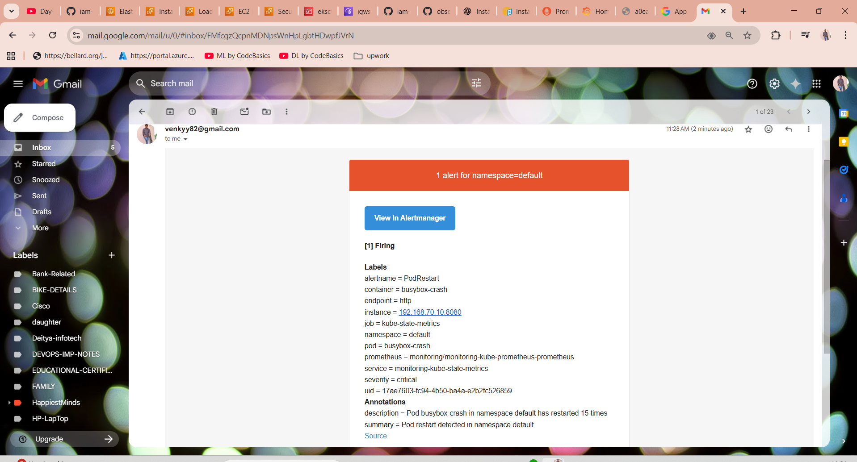

In alerts.yaml file we have configured in a such a so that is why we are getting alerts when ever app is crashing

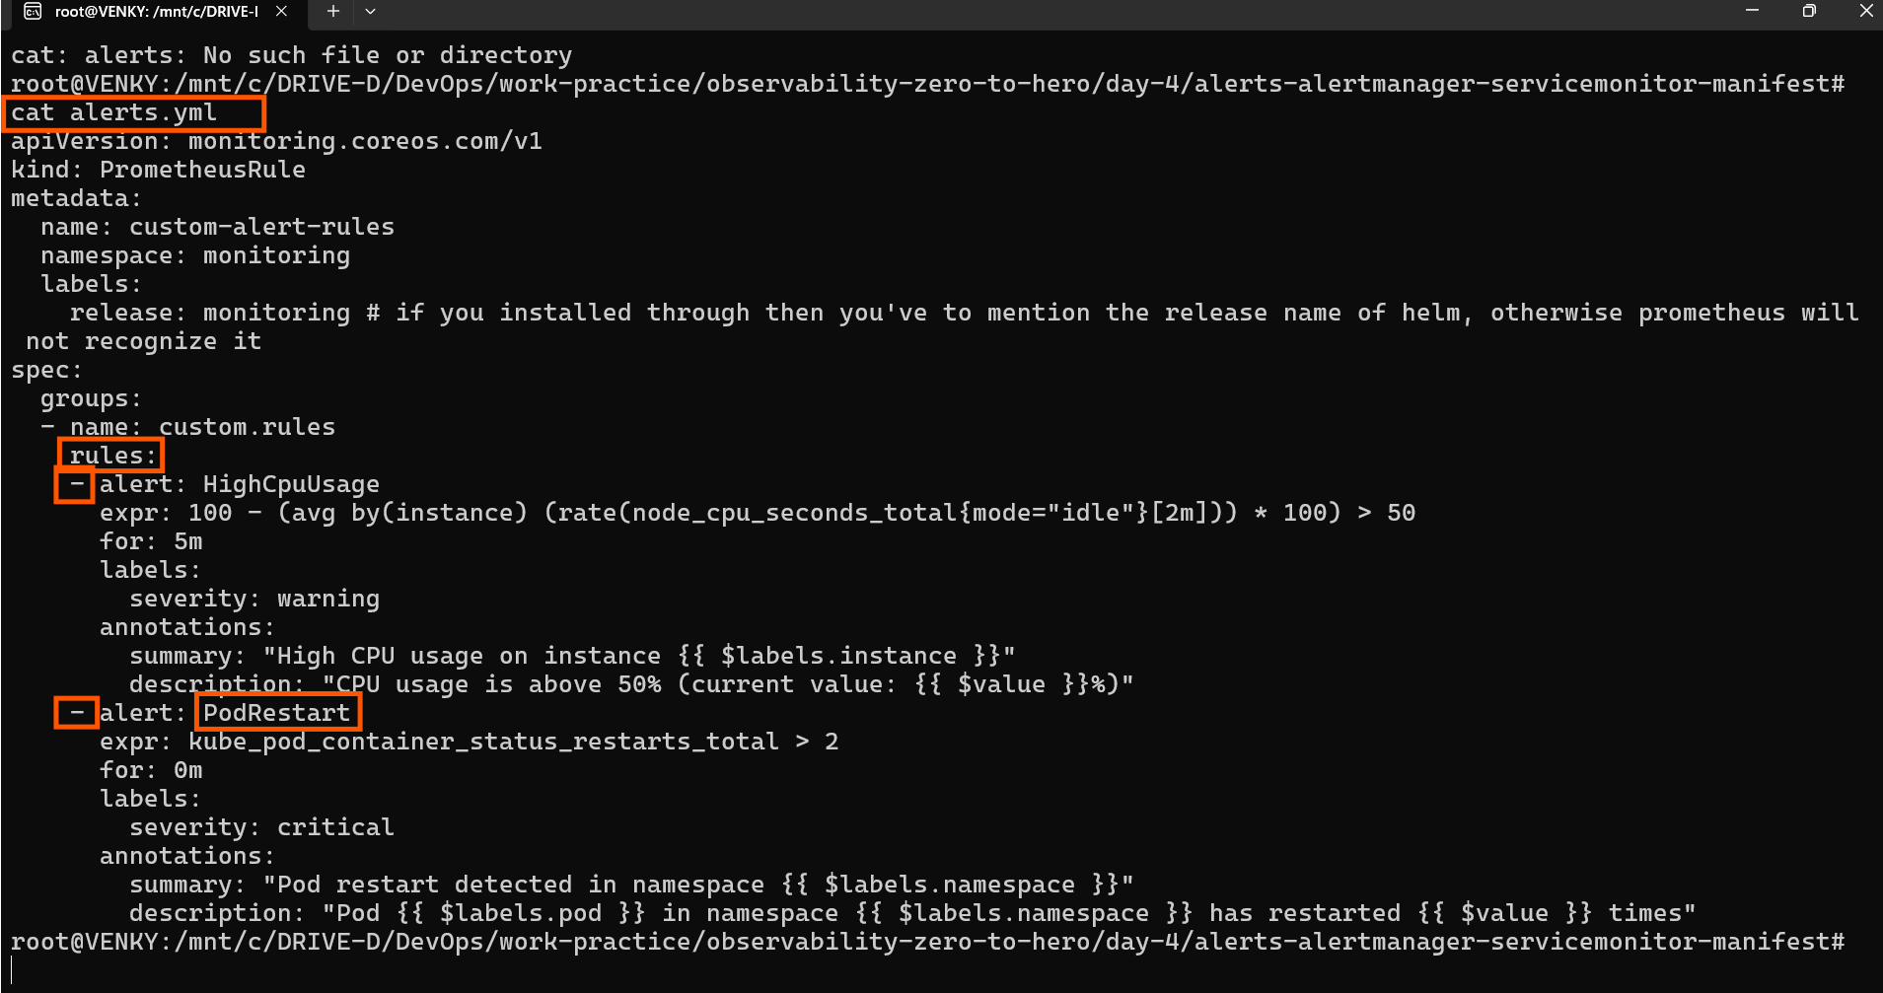

$

EFK Stack:

eksctl create iamserviceaccount \

--name ebs-csi-controller-sa \

--namespace kube-system \

--cluster observability \

--role-name AmazonEKS_EBS_CSI_DriverRole \

--role-only \

--attach-policy-arn arn:aws:iam::aws:policy/service-role/AmazonEBSCSIDriverPolicy \

--approve

$

eksctl create iamserviceaccount \

--name ebs-csi-controller-sa \

--namespace kube-system \

--cluster observability \

--attach-policy-arn arn:aws:iam::aws:policy/service-role/AmazonEBSCSIDriverPolicy \

--role-name EBSCSIDriverRole-Observability \

--approve

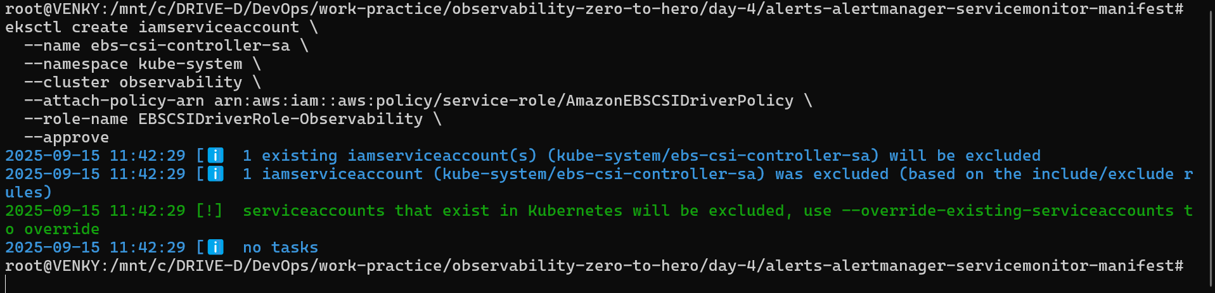

**Retrieve IAM Role ARN**

ARN=$(aws iam get-role --role-name AmazonEKS_EBS_CSI_DriverRole --query 'Role.Arn' --output text)

**Deploy EBS CSI Driver**

eksctl create addon --cluster observability --name aws-ebs-csi-driver --version latest \

--service-account-role-arn $ARN –force

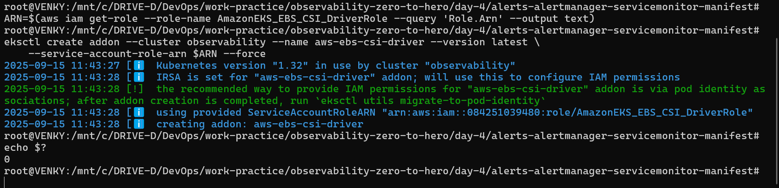

CSI Driver part completed now need to setup EFK Stack

**Create Namespace for Logging**

kubectl create namespace logging

**Install Elasticsearch on K8s**

helm repo add elastic https://helm.elastic.co

helm install elasticsearch \

--set replicas=1 \

--set volumeClaimTemplate.storageClassName=gp2 \

--set persistence.labels.enabled=true elastic/elasticsearch -n logging

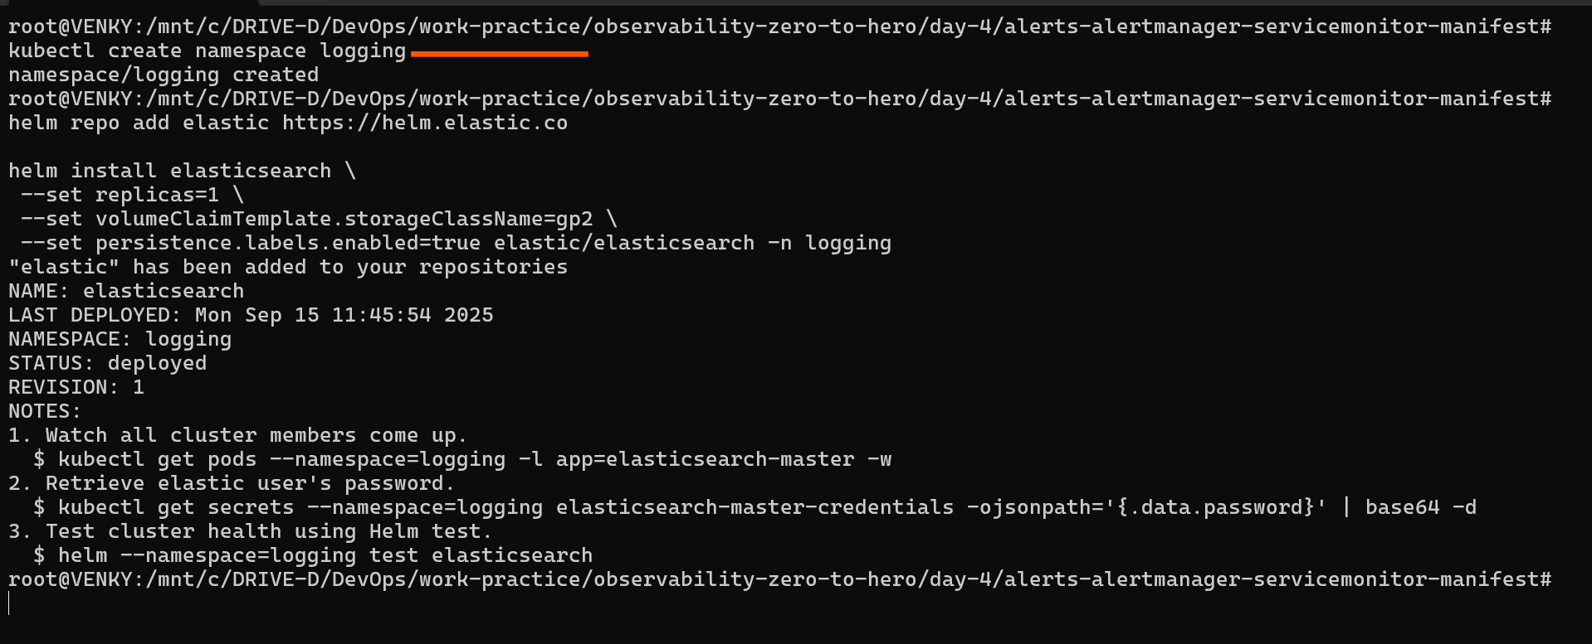

**Retrieve Elasticsearch Username & Password**

# for username

kubectl get secrets --namespace=logging elasticsearch-master-credentials -ojsonpath='{.data.username}' | base64 -d

# for password

kubectl get secrets --namespace=logging elasticsearch-master-credentials -ojsonpath='{.data.password}' | base64 -d

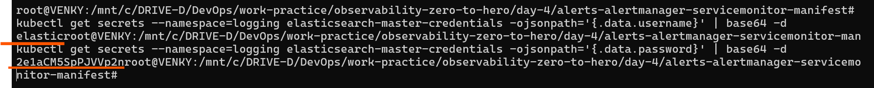

**Install Kibana**

helm install kibana --set service.type=LoadBalancer elastic/kibana -n logging

**Install Fluentbit with Custom Values/Configurations**

Before installing fluentbit update values of fluentbit-values.yaml file of password of elasticsearch

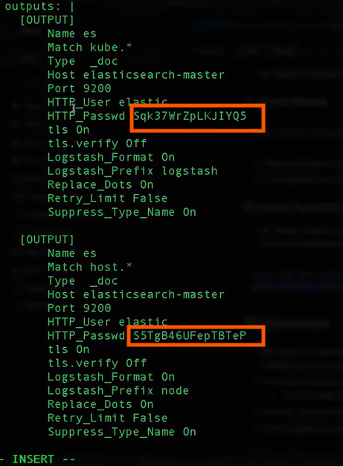

helm repo add fluent https://fluent.github.io/helm-charts

helm install fluent-bit fluent/fluent-bit -f fluentbit-values.yaml -n logging

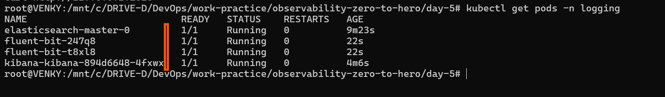

Kubectl get service/svc

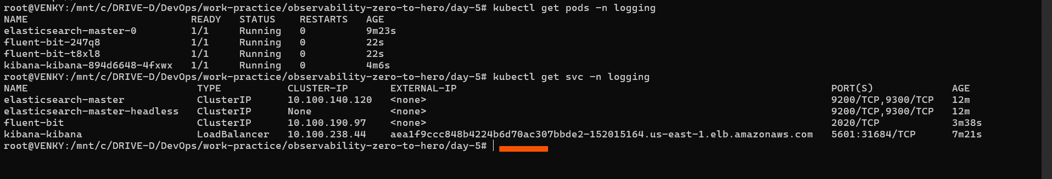

We can access the kibana

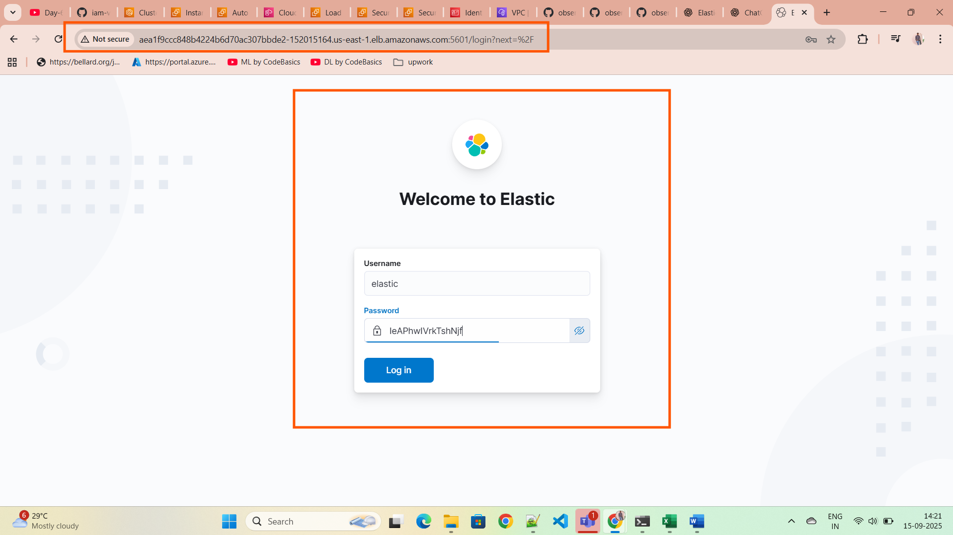

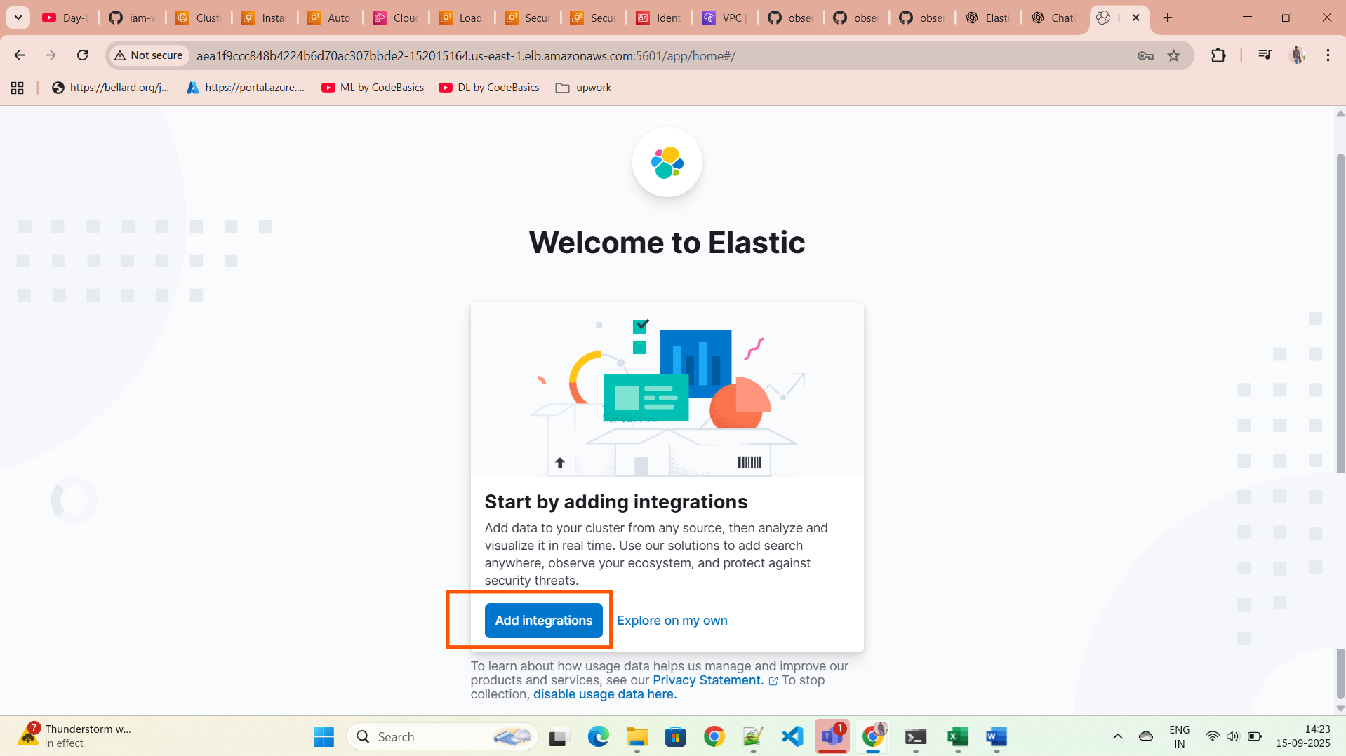

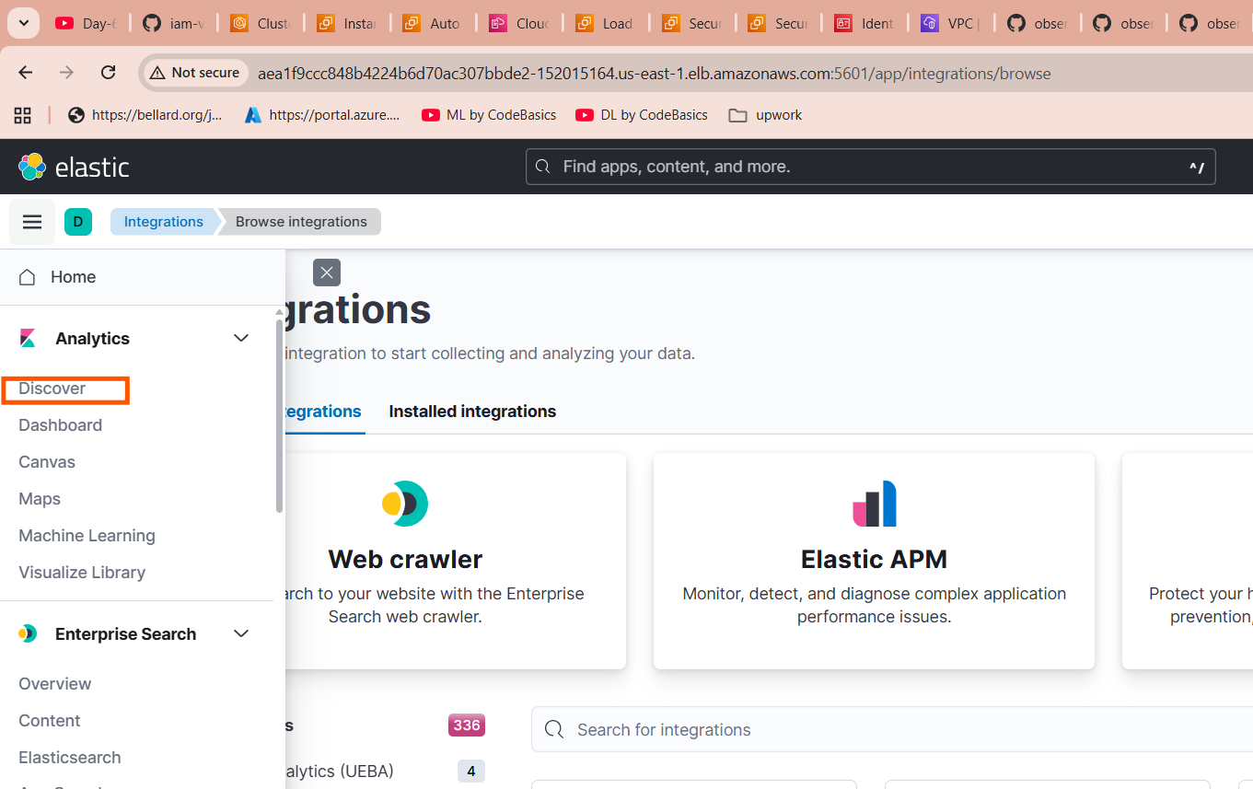

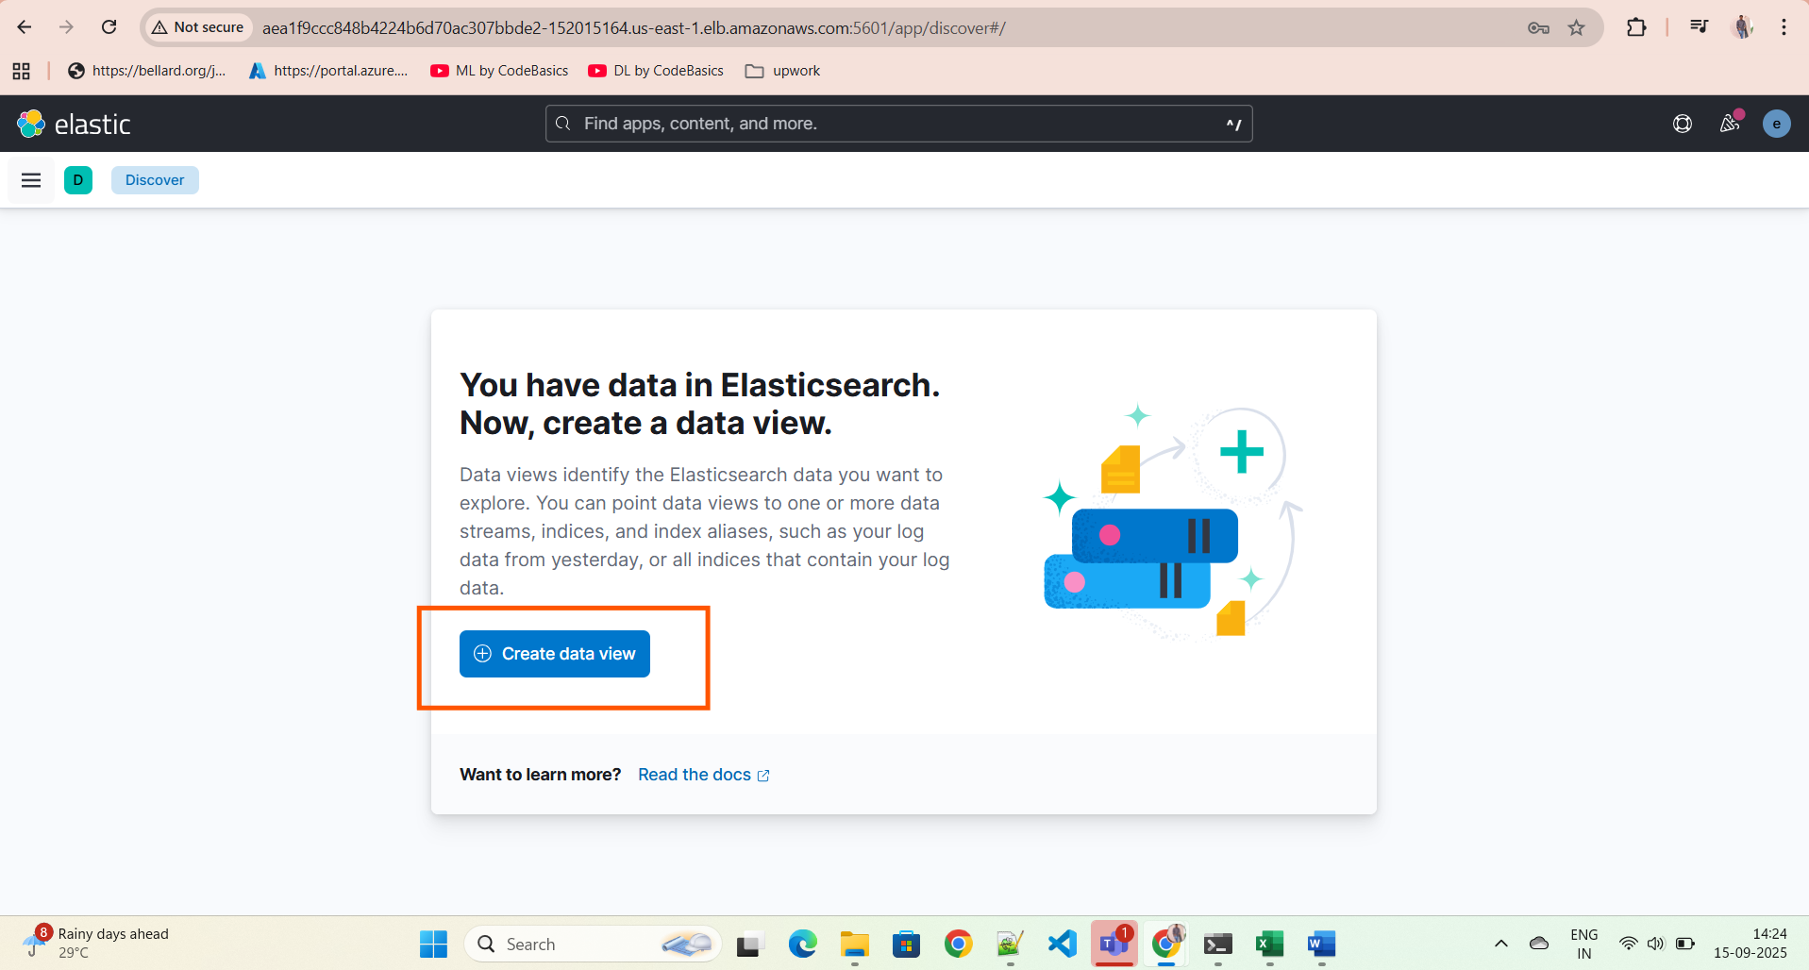

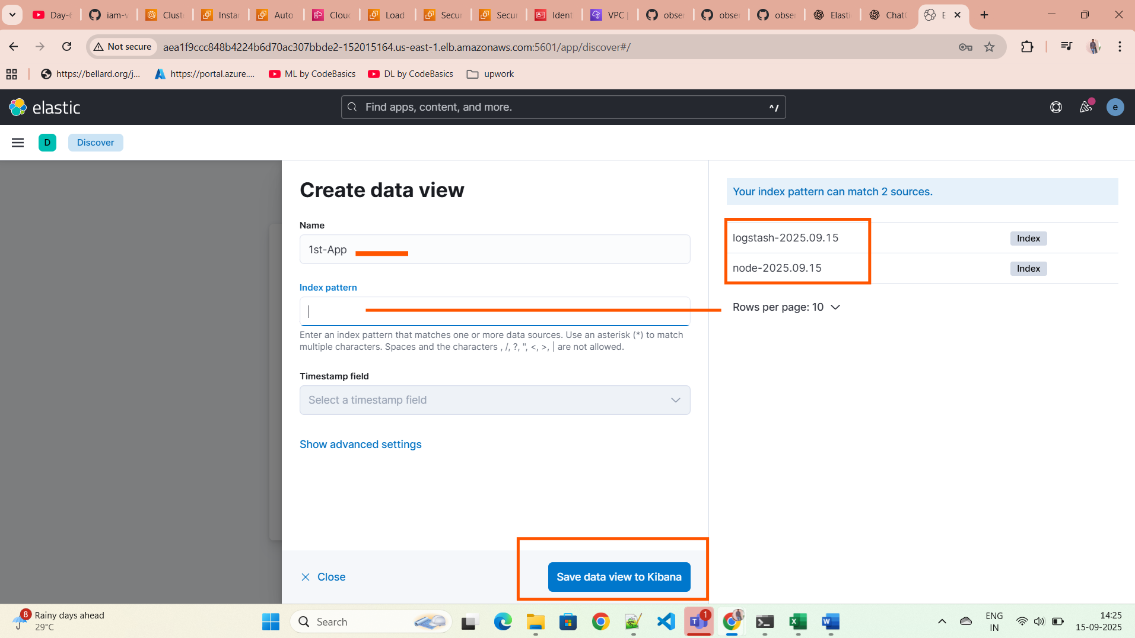

We have 2 log patterns we can select one log pattern

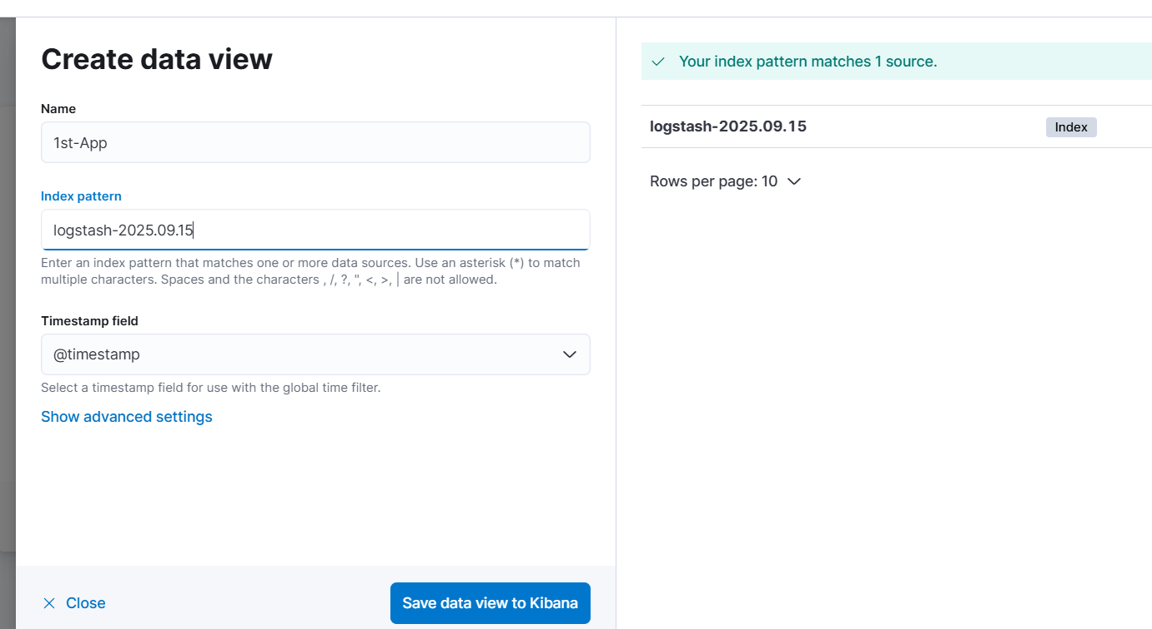

We can see the logs in kibana

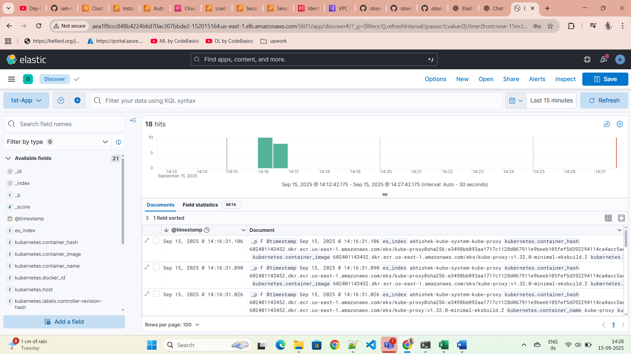

We can install any demo app and we can monitor also

We no need to change/update the configurations of directory structure. Run below commands to install/host an app

kubectl create ns dev

kubectl apply -k kubernetes-manifest/

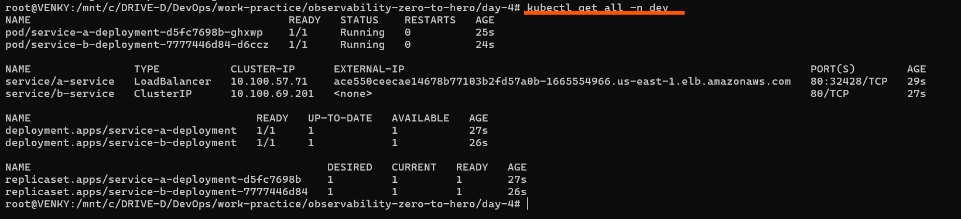

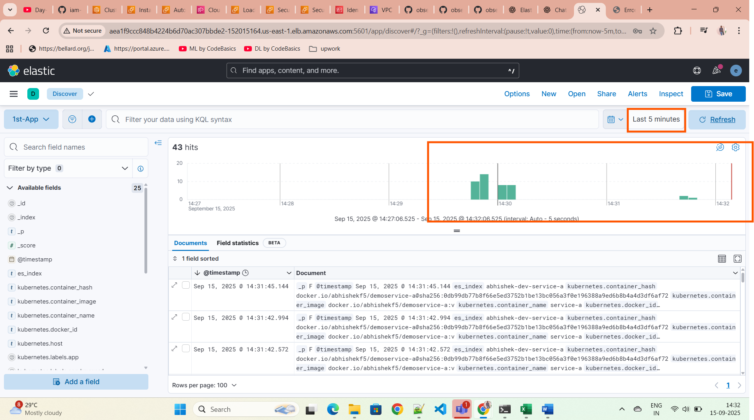

We can also filter the logs by searching kibana Query Language

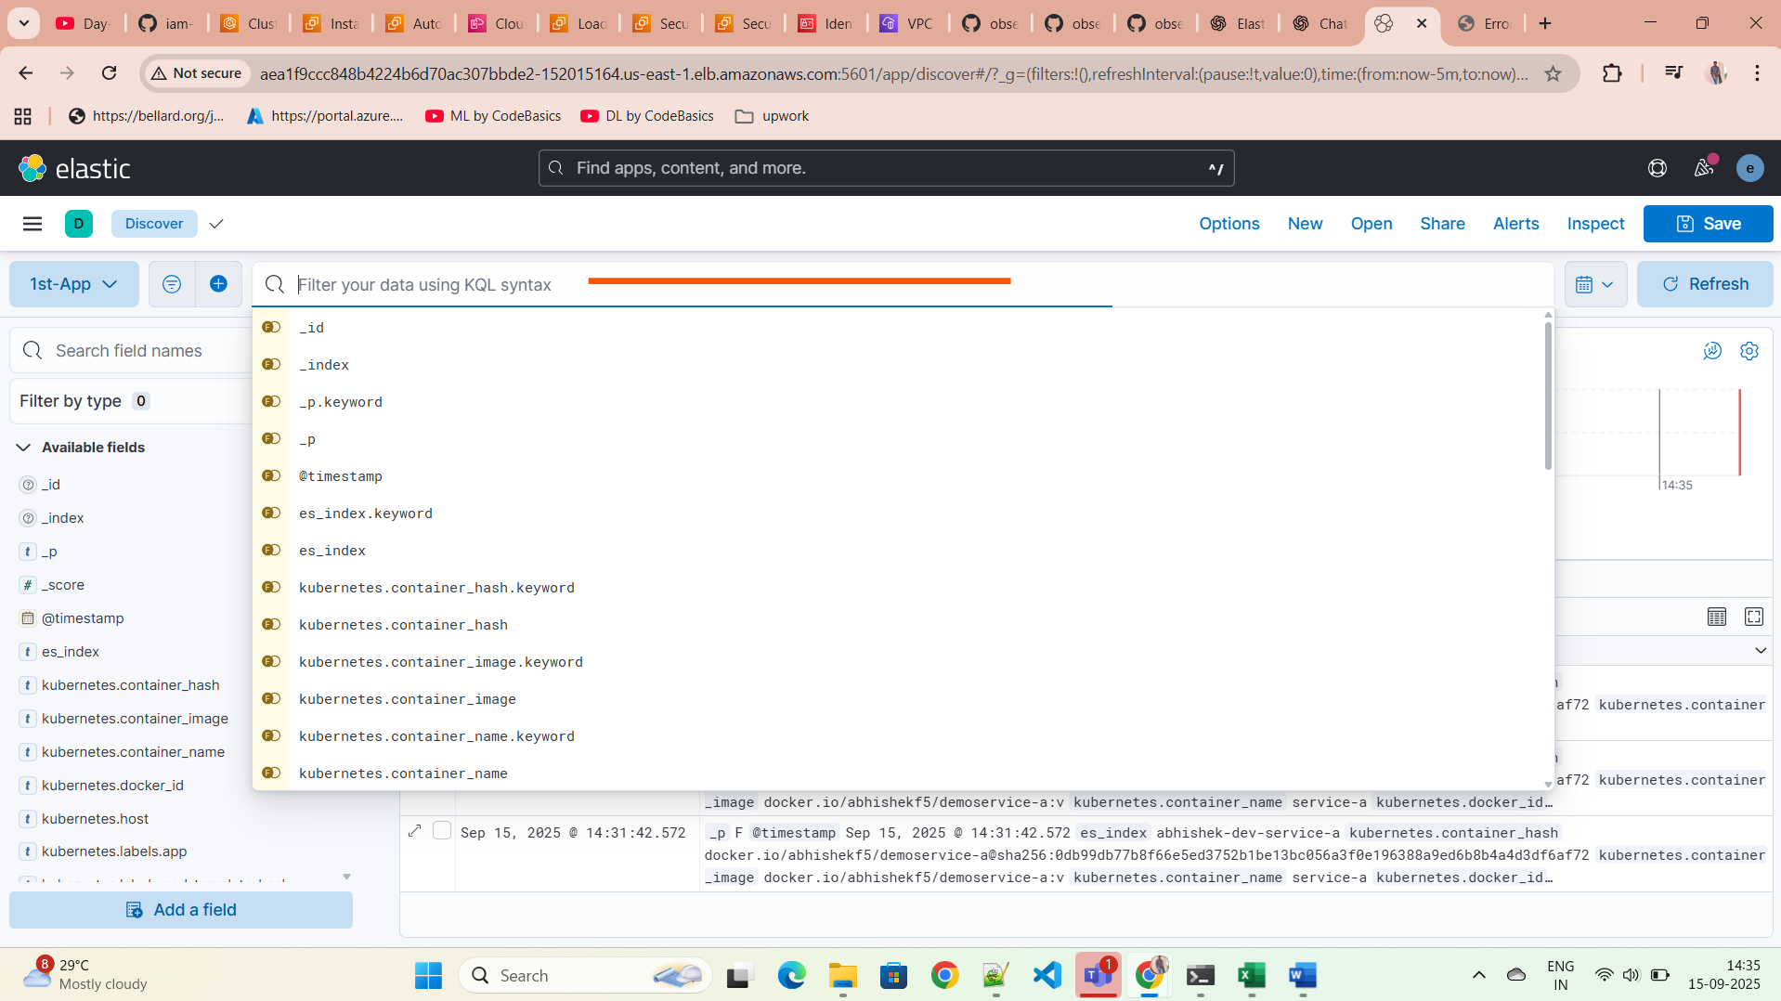

If we keep on hitting the deployed app like /health & /metrics & /logs & /metrics we can see no. of hits increased

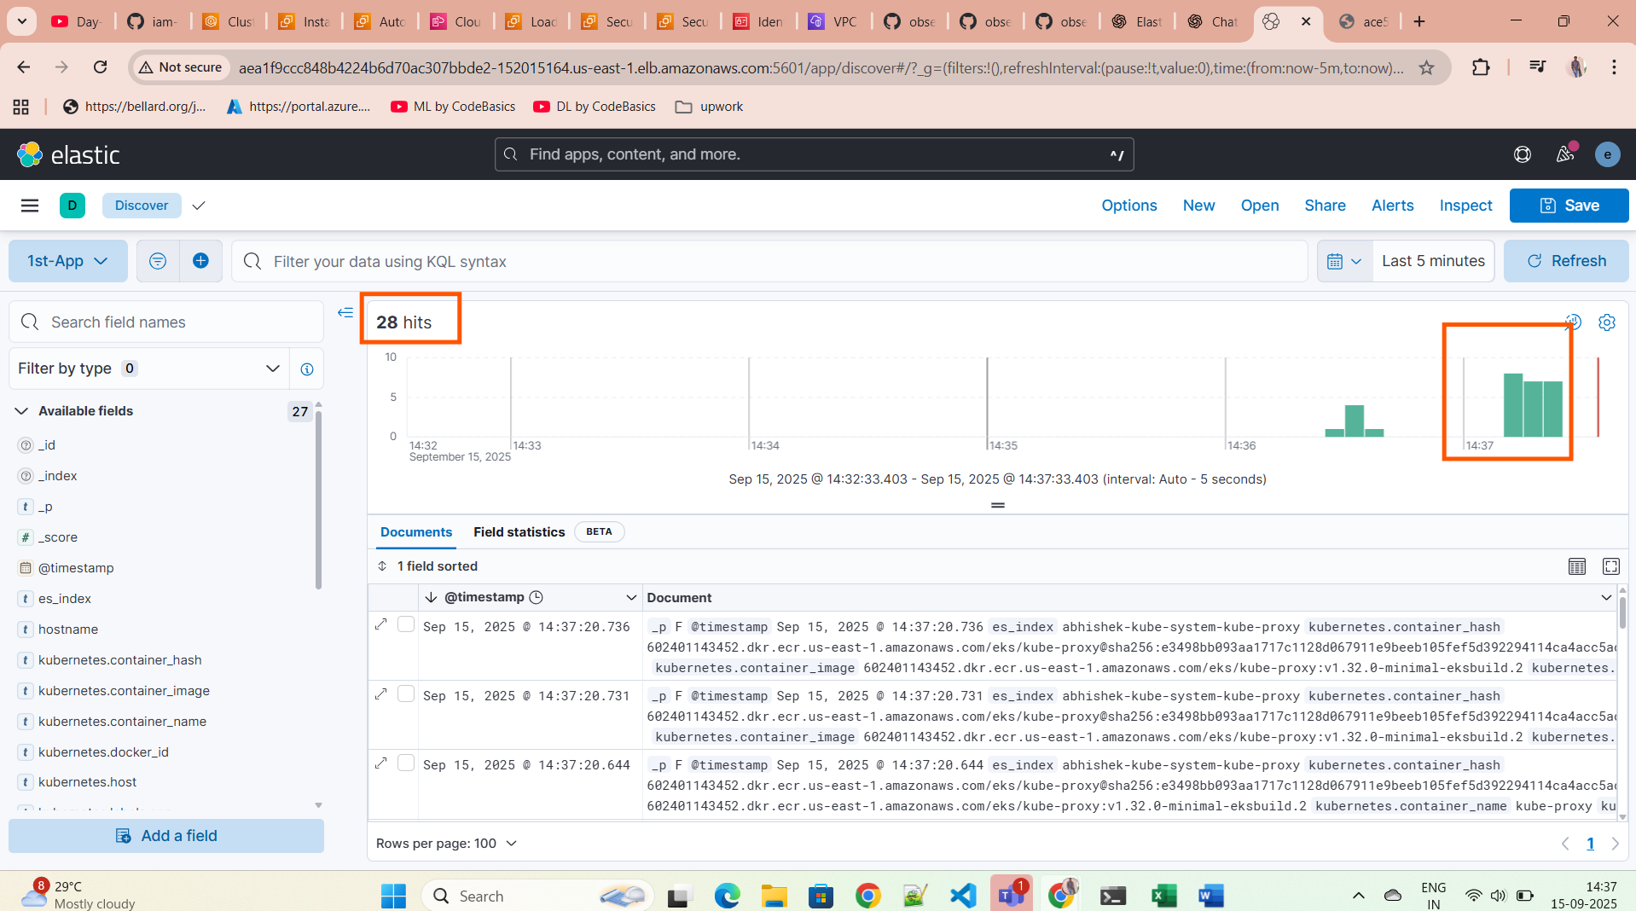

If we login to ec2 instance we can see the logs files path

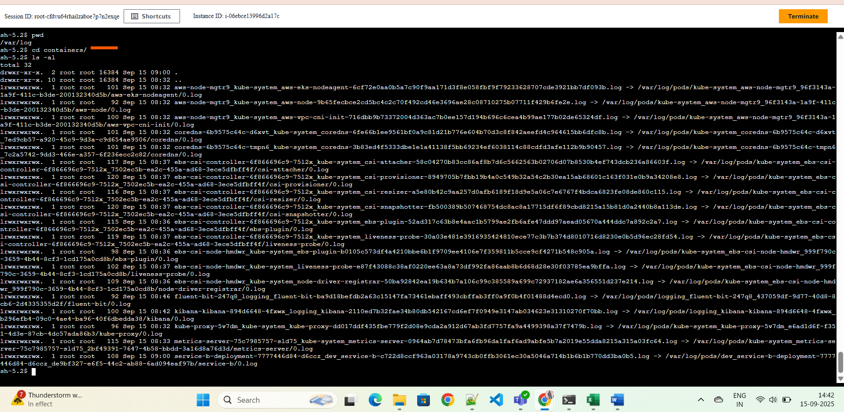

I intentionally crashed the application

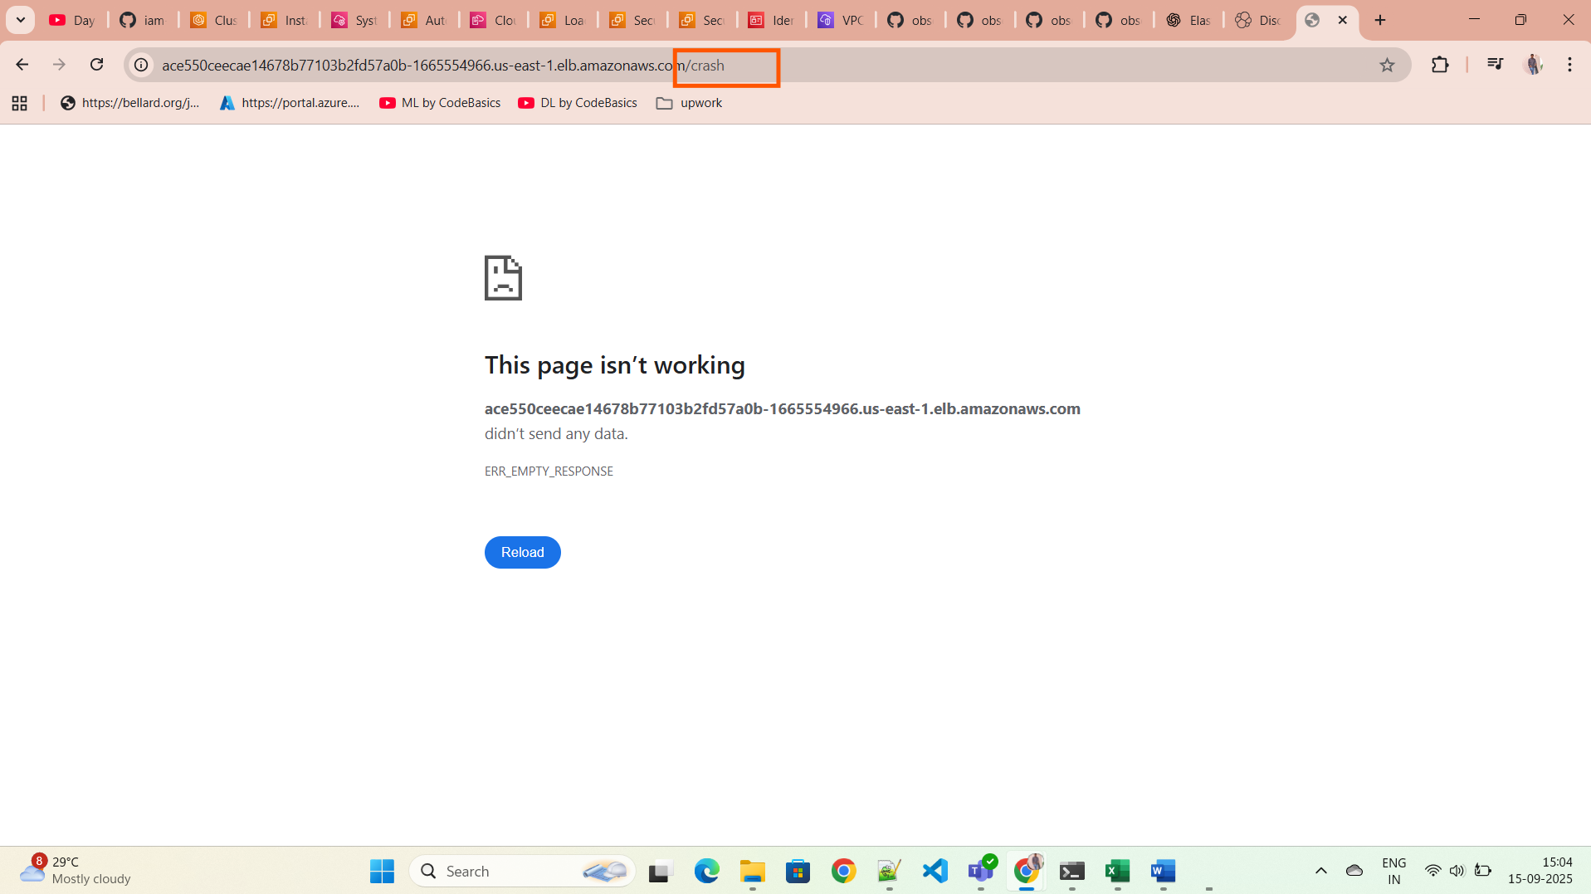

Now we can see those logs here clearly in the kibana

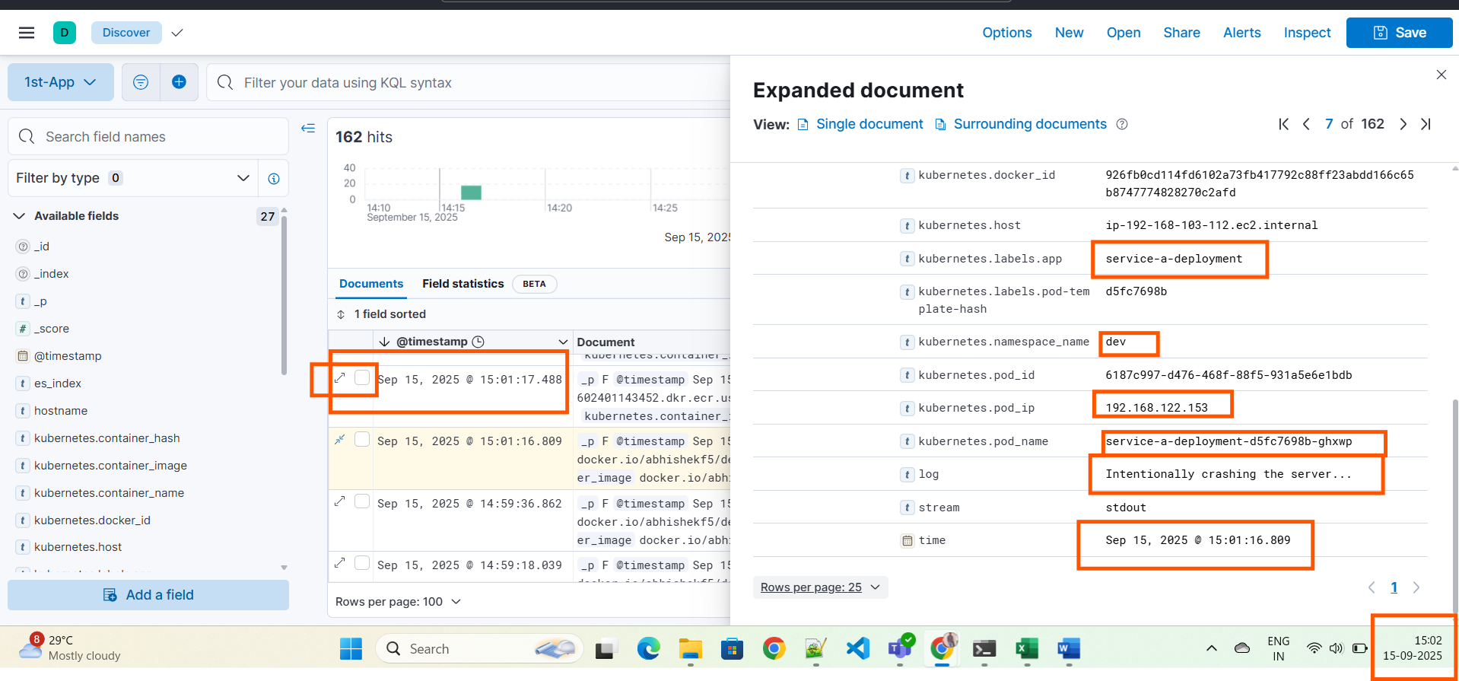

We can query the logs

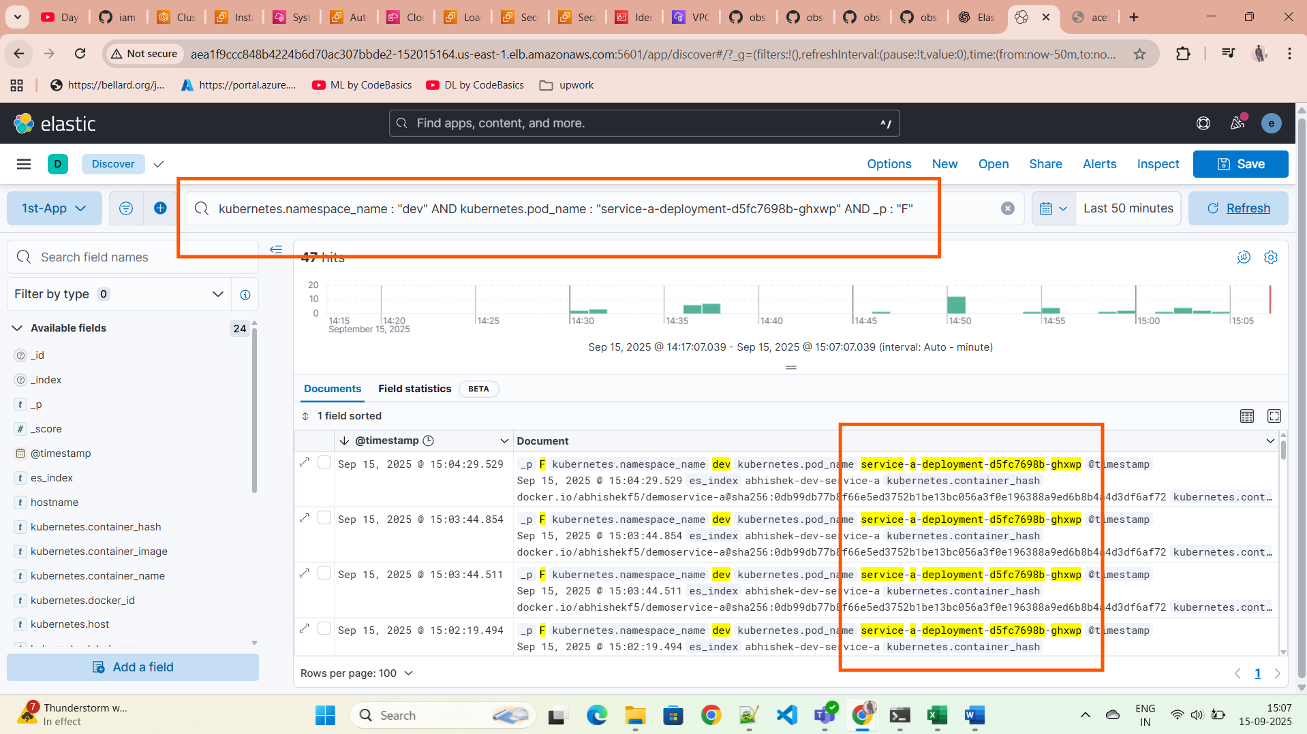

We can delete the eks cluster setup by using the command

eksctl delete cluster --name your-cluster-name

Troubleshooting commands:

kubectl delete all --all -n logging

kubectl delete configmap --all -n logging

kubectl delete secret --all -n logging

kubectl delete pvc --all -n logging

kubectl delete ingress --all -n logging

kubectl delete serviceaccount pre-install-kibana-kibana -n logging

kubectl delete configmap kibana-kibana-helm-scripts -n logging

# You can check for any leftover resources using:

kubectl get all -n logging

kubectl get configmaps -n logging

kubectl get serviceaccounts -n logging

kubectl get roles -n logging

kubectl get rolebindings -n logging

kubectl delete role pre-install-kibana-kibana -n logging

kubectl delete rolebinding pre-install-kibana-kibana -n logging